# Restful Web services

1. Introduction
   1. Light weight
   2. Rest send messages using XML or JSON
   3. Service Definition
      1. WSDL is used in the SOAP web services where as no definition is used in REST
   4. 
2. REST and HTTP
   1. 
   2. HTML Concepts
      1. Resource allocation
   3. HTTP Methods - GET, POST, PUT, DELETE
   4. MetaData -
   5. HTTP Status codes
   6. 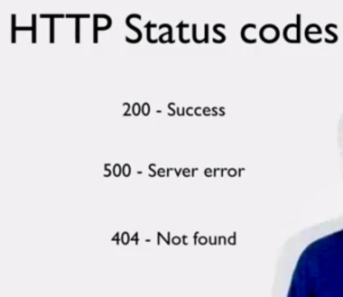
   7. Header value - content type
   8. 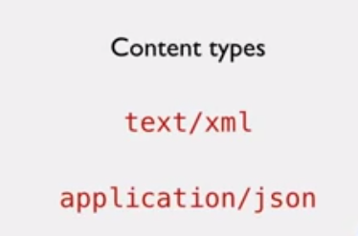
   9. Content Negotiation
   10. 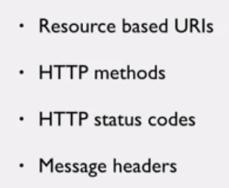
3. Web Application URI
   1. 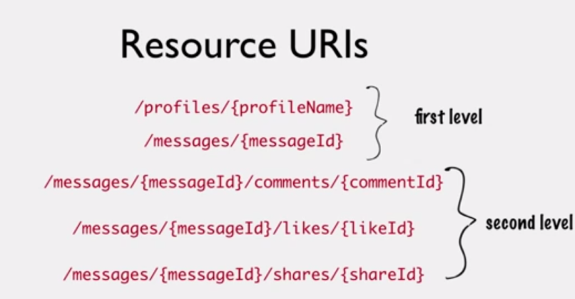
4. Collection URI
   1. 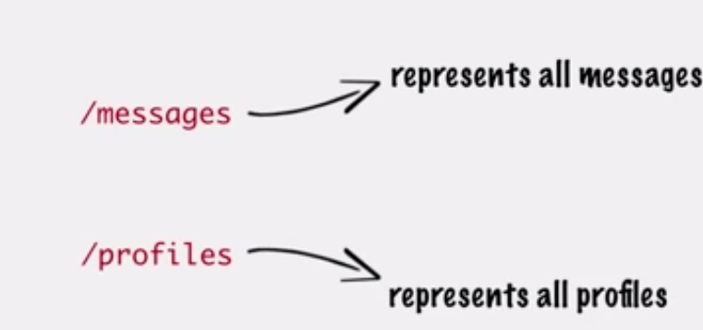
   2. 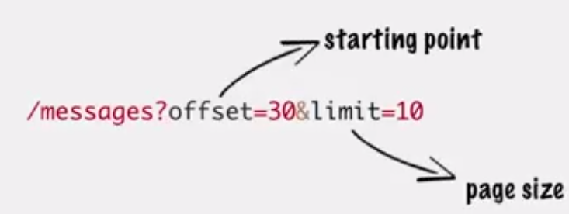
   3. 
   4. 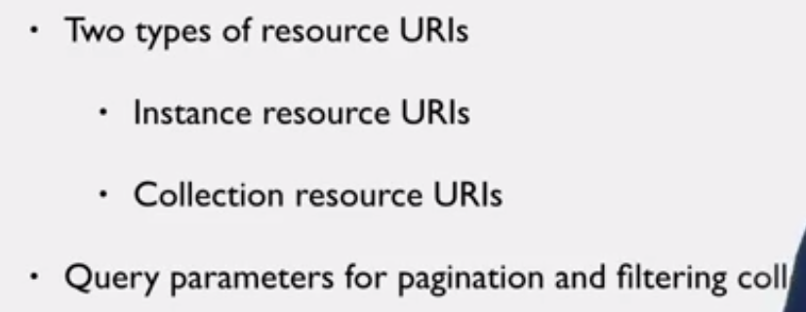Collection parameters
5. HTTP Methods
   1. 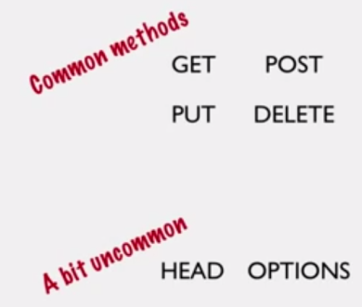
   2. 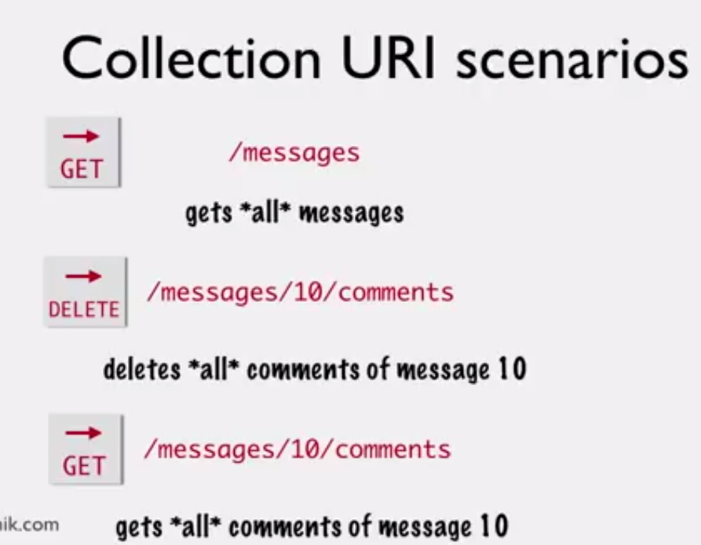
   3. 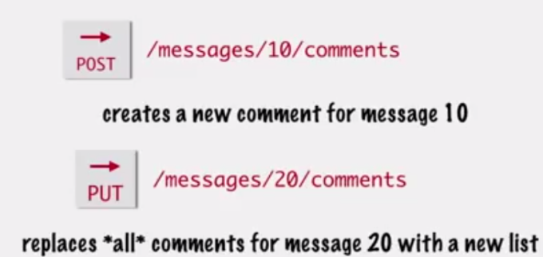
   4. 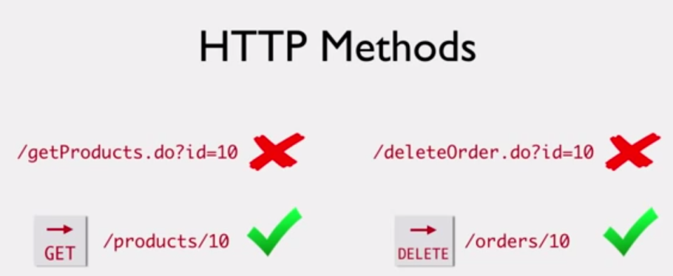
   5. 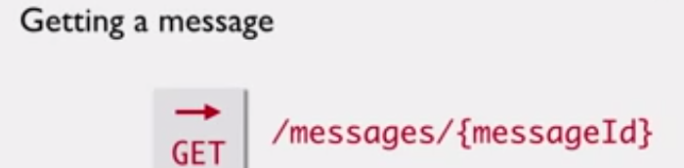
   6. 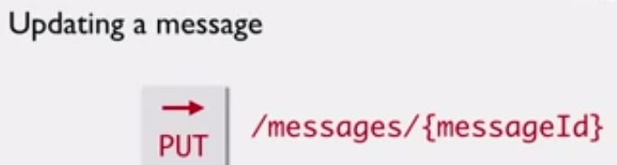
   7. 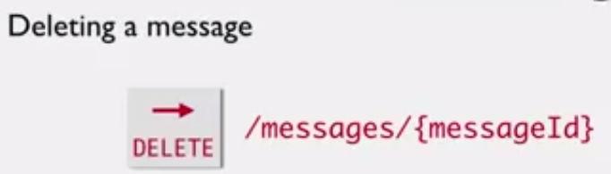
   8. 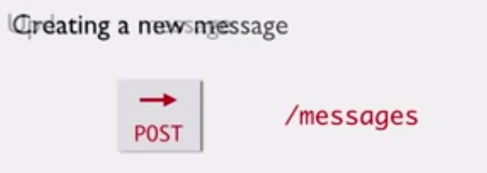 the response have the created message id
6. Method Idempotence
   1. 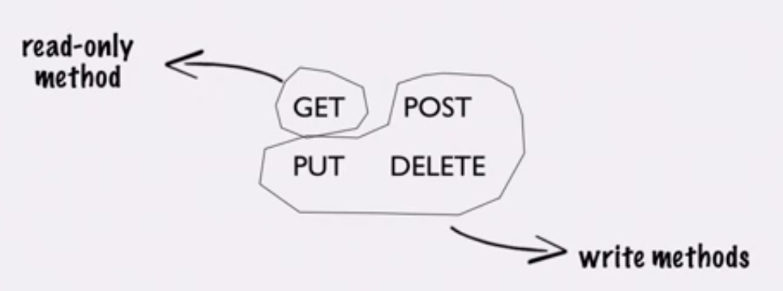
   2. GET - retrieve ,PUT - updates, POST - Submits(Create), and the DELETE - Deletes the data
   3. we can make repeated calls for GET, PUT(Replaces), and DELETE(Does nothing if not data found for that message). But for post if we do multiple times it will create and new duplicate messages.
   4. 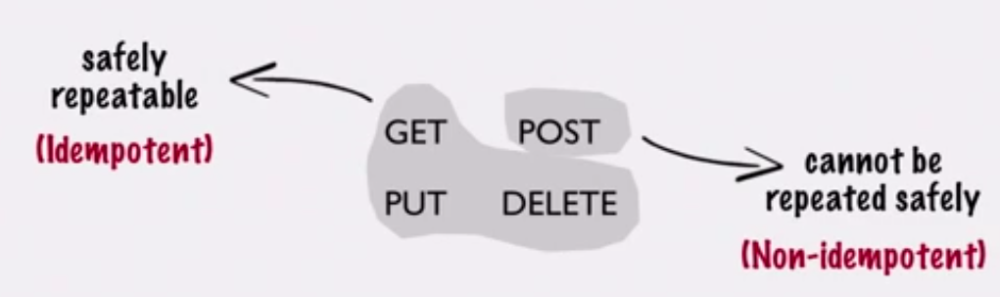
   5. 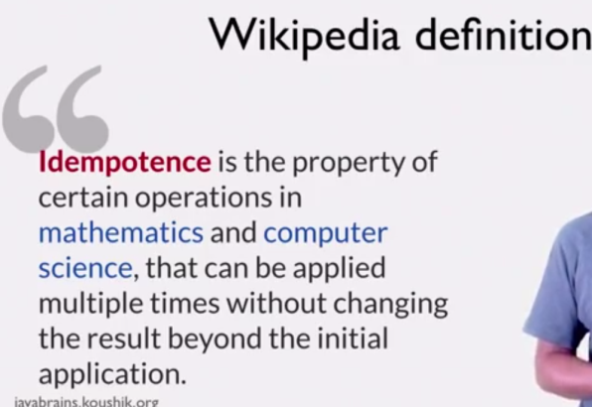
7. REST Response
   1. JSON
   2. 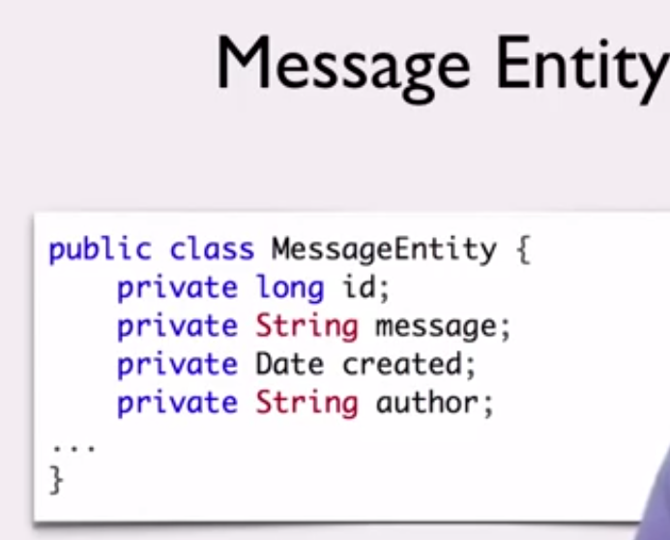
   3. 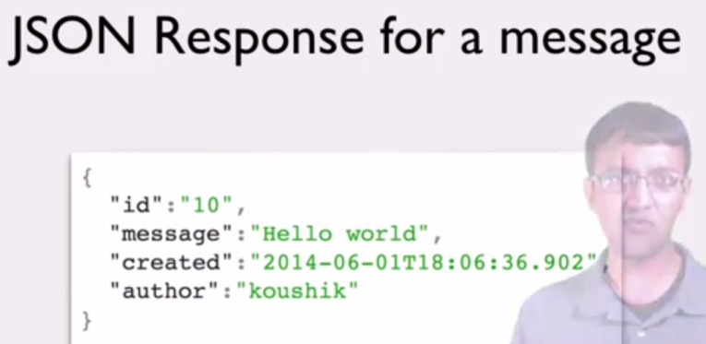
   4. 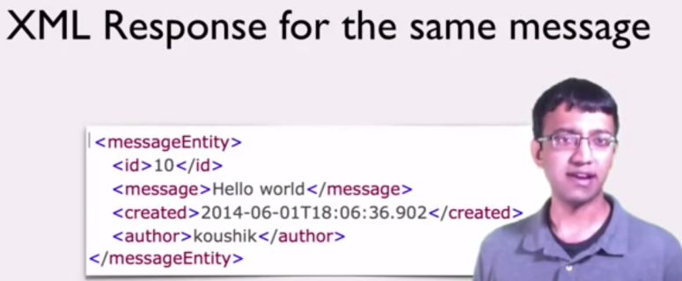
   5. The Content type in the Req/Res headers we can determine the type either JSON or XML .
   6. 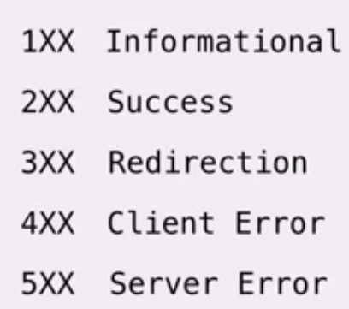
   7. 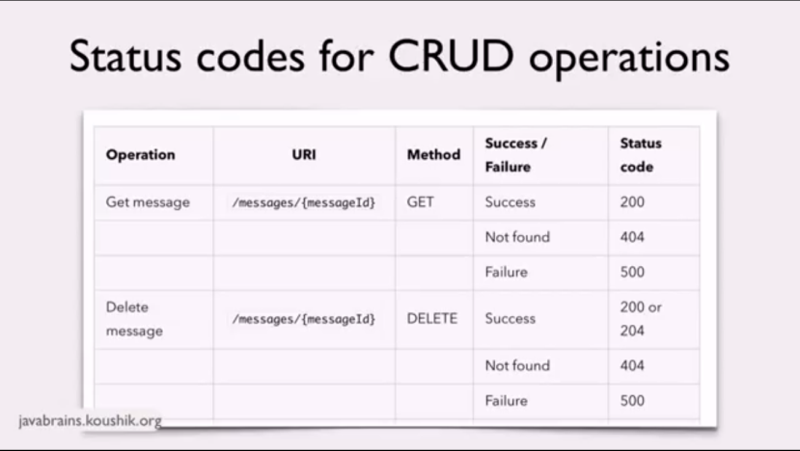
   8. 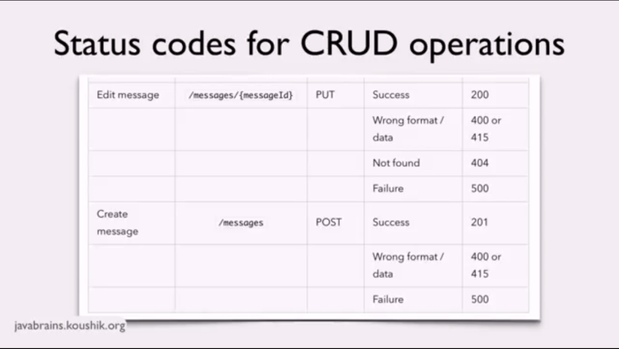
   9. 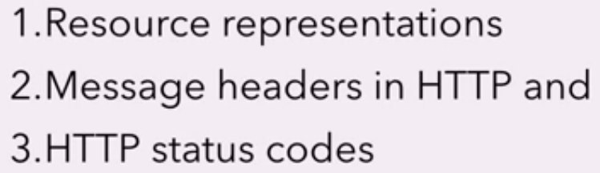
8. HATEOAS
   1. 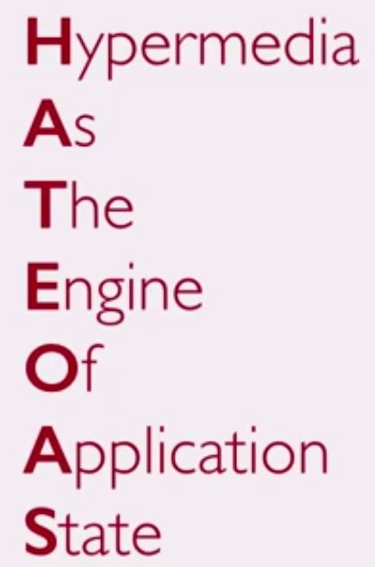
   2. 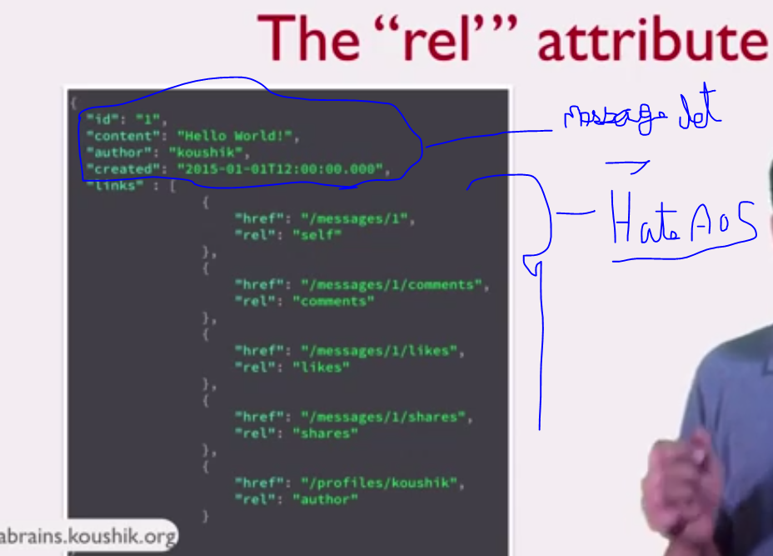
   3. HATEAOS - is a way to provide links to resources in the API Response
9. The Richardson Maturity Model
   1. Model to identify the API is rest and its level
   2. Four level : Level 0, Level 1, Level 2, Level 3.
   3. 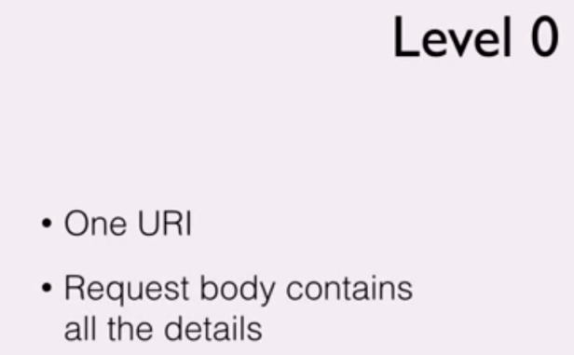
   4. 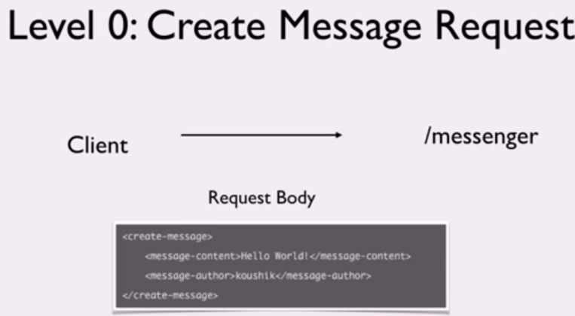
   5. 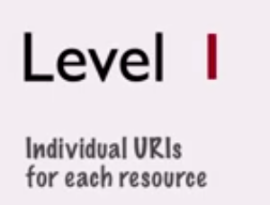
   6. 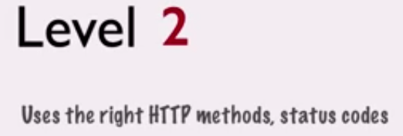
   7. 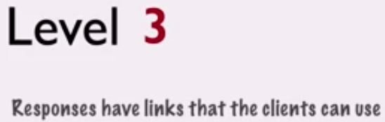
10. Jar-RS
    1. REST -API Libraries
       1. Resteasy
       2. RESTLet
       3. Jersey
    2. All the above libraries follow same Interface - Jax-RS
    3. 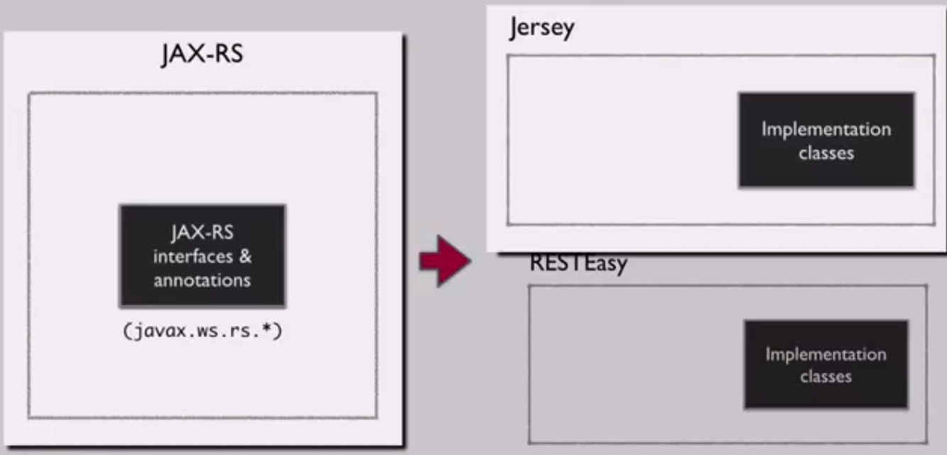
11. SetUp
    1. Create a new maven project
    2. 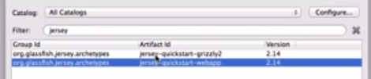
    3. if this does not exist add a new by "add Archetype".
    4. 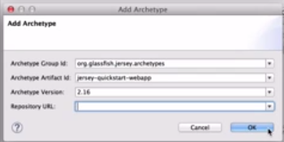
    5. 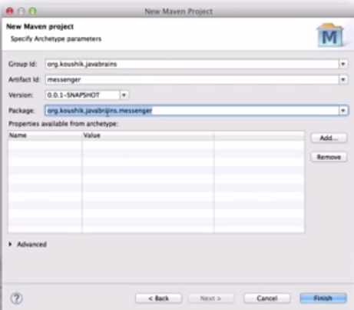
    6. Add a tomcat server and run the project
    7. 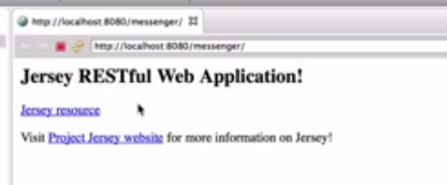
12. Application Structure
    1. 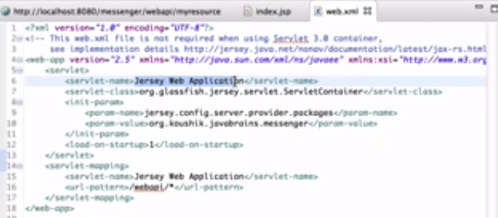
13. Creating a new resources
    1. 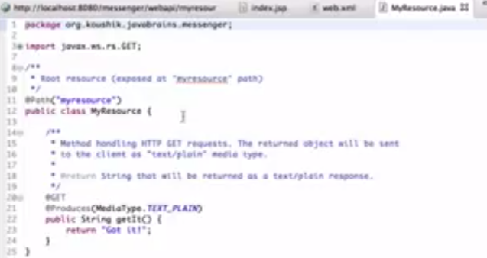
    2. Create a new class.
    3. Annotate the class with @path
    4. 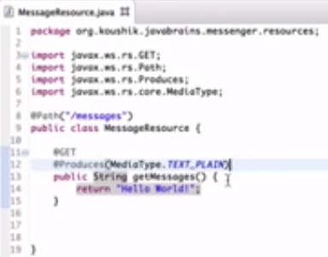
14. Returning XML Response
    1. Create a message pojo class
    2. 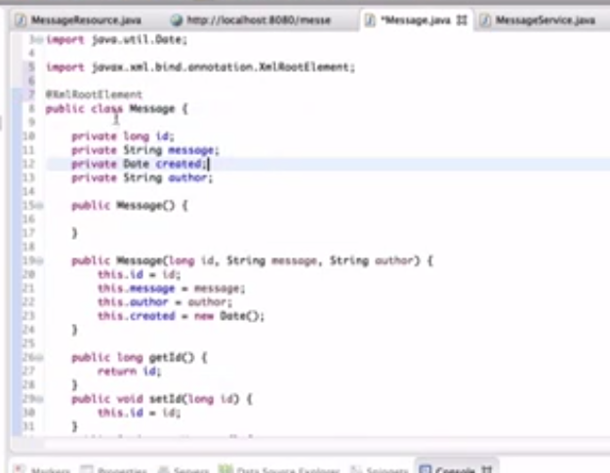
    3. 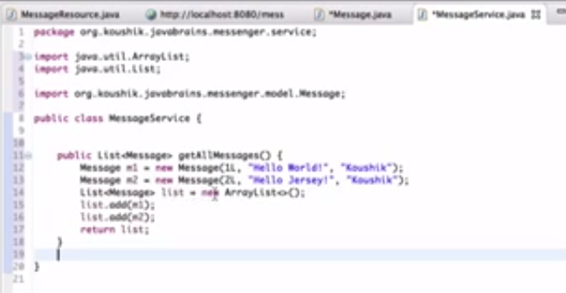
    4. 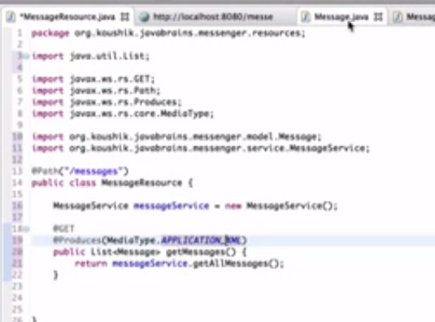
15. Installing a REST API client
    1. Postman and test the rest services
    2. 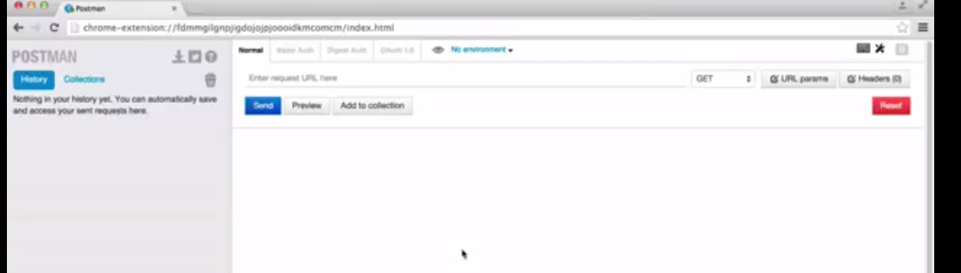
16. Building a service stub
    1. 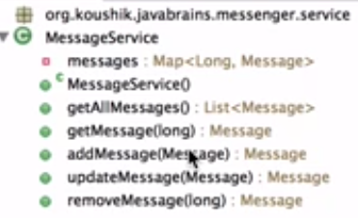
    2. 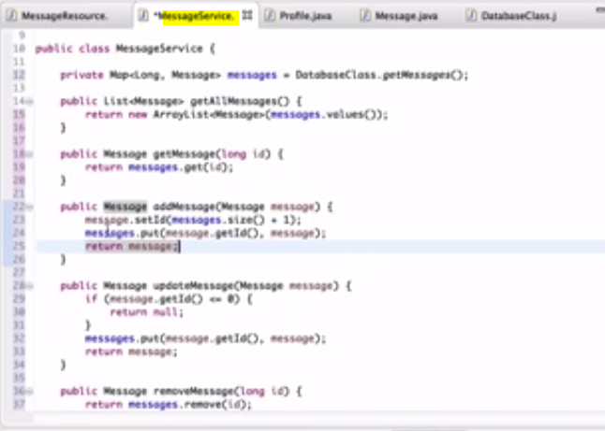
    3. 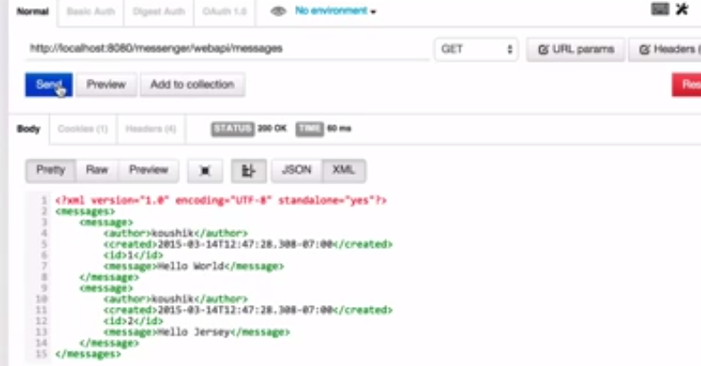
17. Accessing path param
    1. 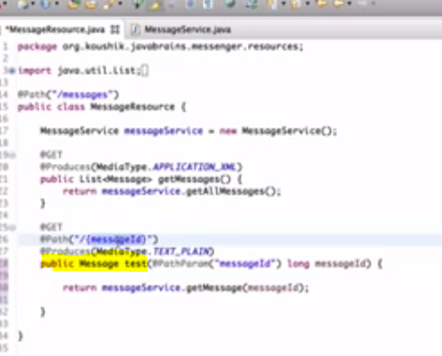
18. Returning JSON Response
    1. 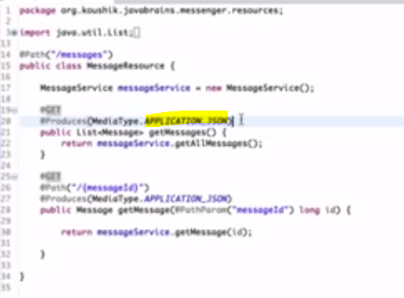
    2. 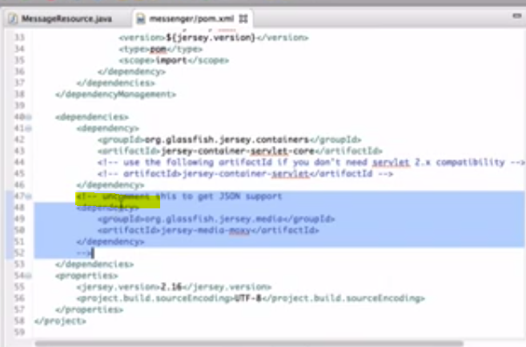
    3. 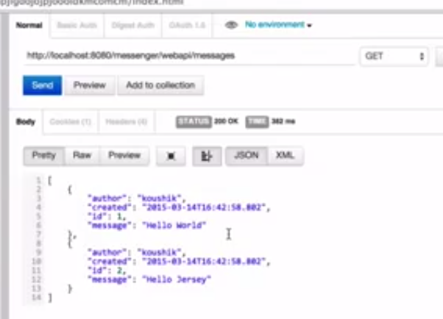
19. Implementing POST Method
    1. 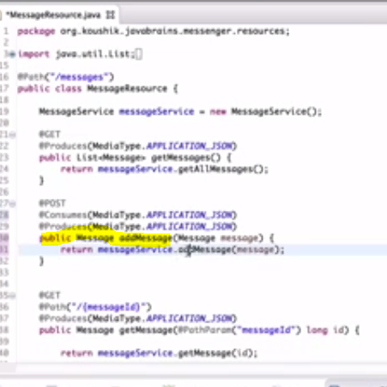
20. Implementing Update and Delete.
    1. 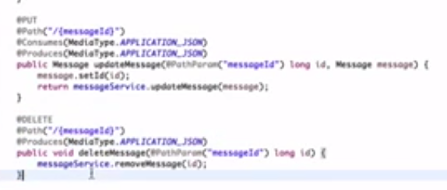
    2. 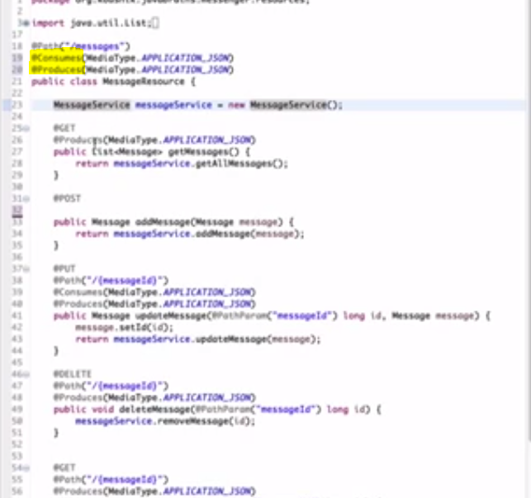
21. Implementing ProfileResource
22. Pagination and filtering
    1. QueryParam
    2. 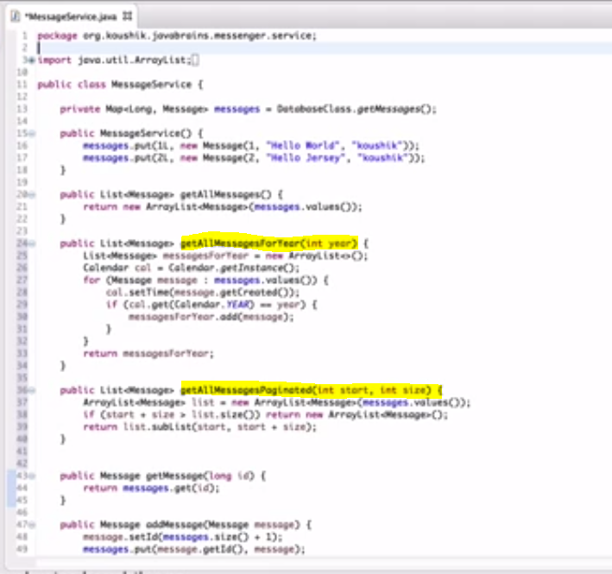
    3. 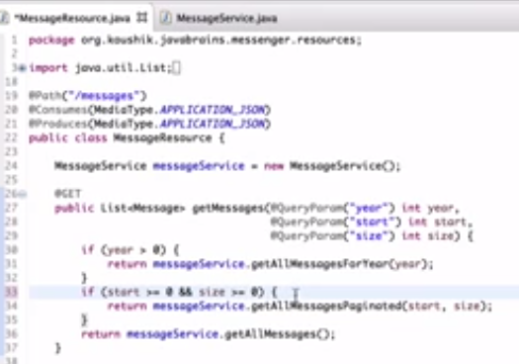
23. The Param Annotations
    1. Matrix param - seperated by ";"
    2. Header Param - in Header
    3. Cokiee param - in Cokiee
    4. 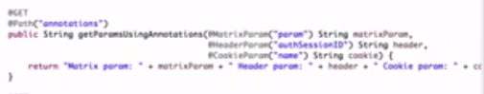
    5. 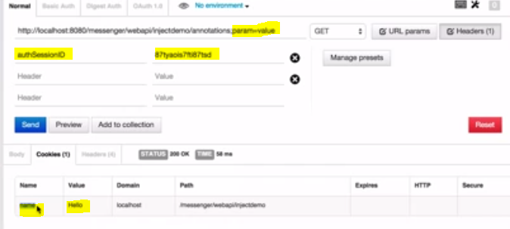
24. Using Context and BeanParam annotations
    1. @context and uriInfo, HttpHeaders
    2. 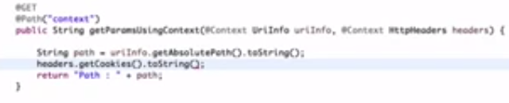
    3. 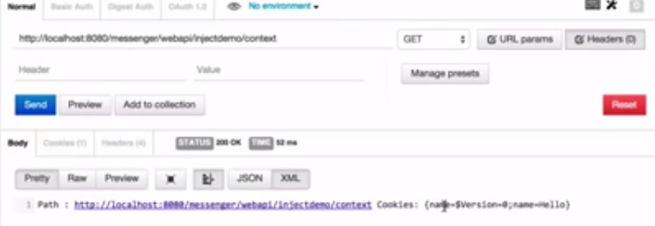
    4. @beanParam
    5. 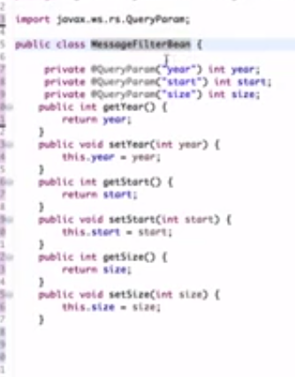
    6. 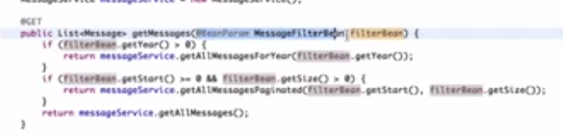
25. Implementing Subresources
    1. 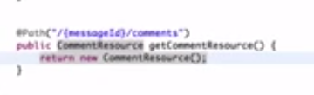
    2. 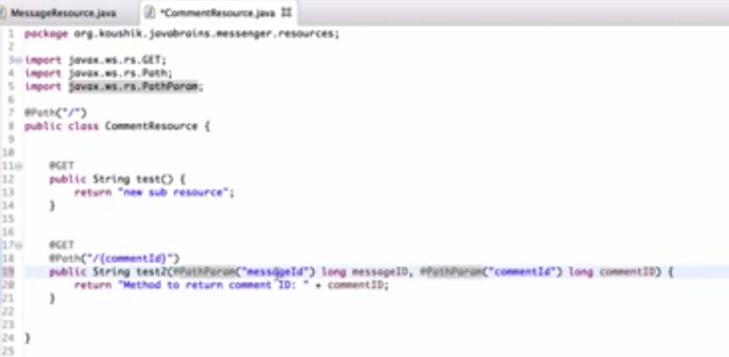
26. Sending Status Codes and Location Headers
    1. 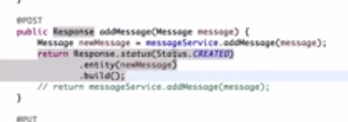
    2. With response we can set cookie, headers, status etc and sent it as a response.
27. Handling Exceptions
    1. 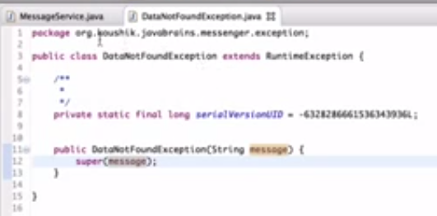
    2. 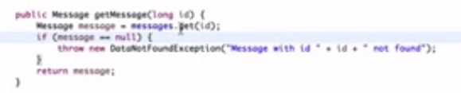
    3. 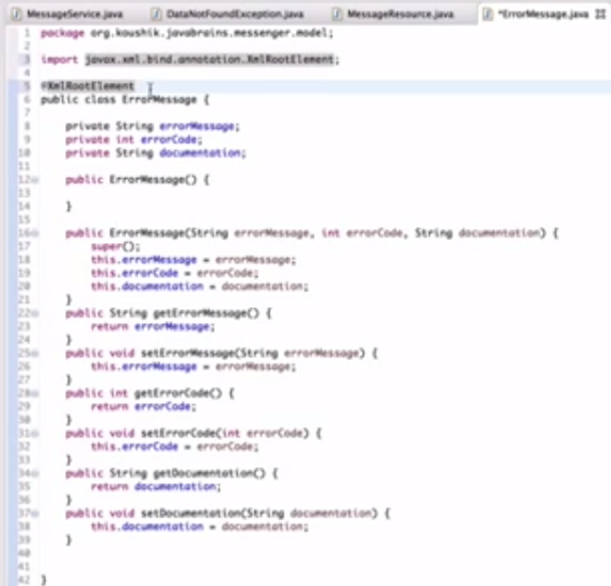
    4. Exception mapper
    5. 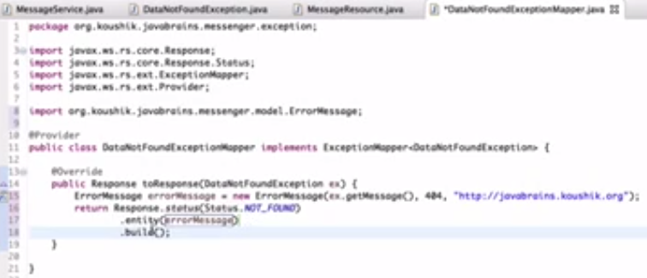
    6. For generic exceptions
    7. 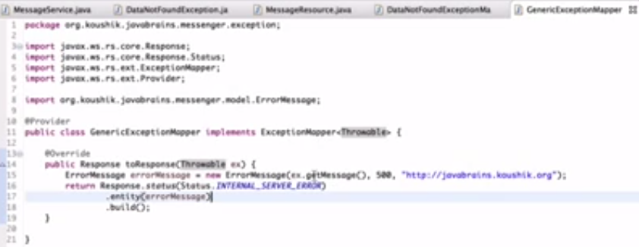
28. Using WebApplicationException
    1. 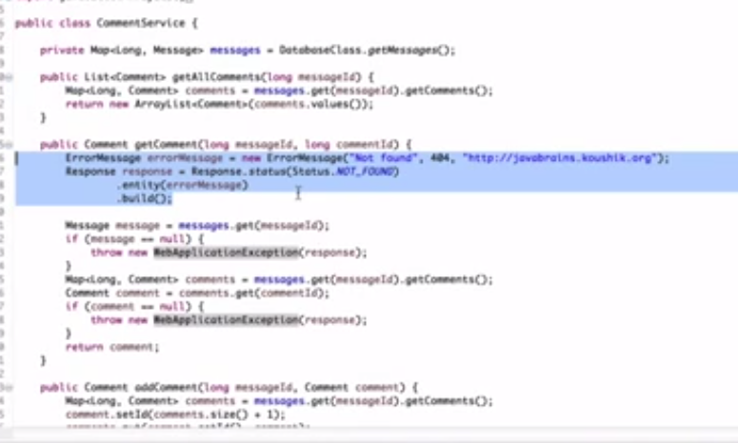
29. HATEOAS (Part 1)
30. HATEOAS (Part 2)
    1. 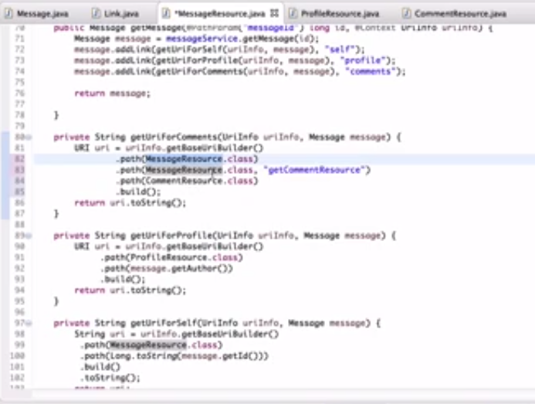
    2. 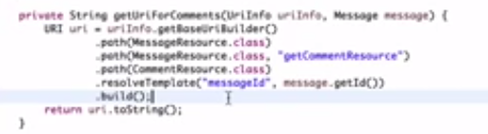
31. Content Negotiation
    1. 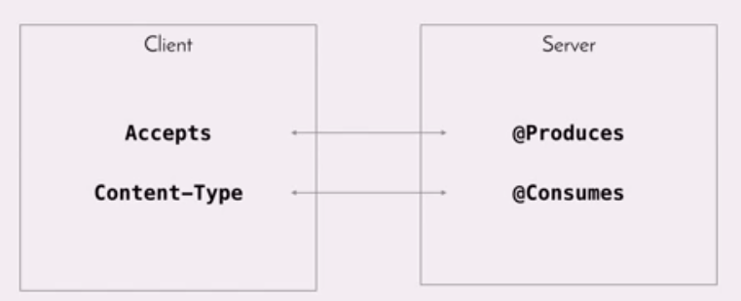
    2. 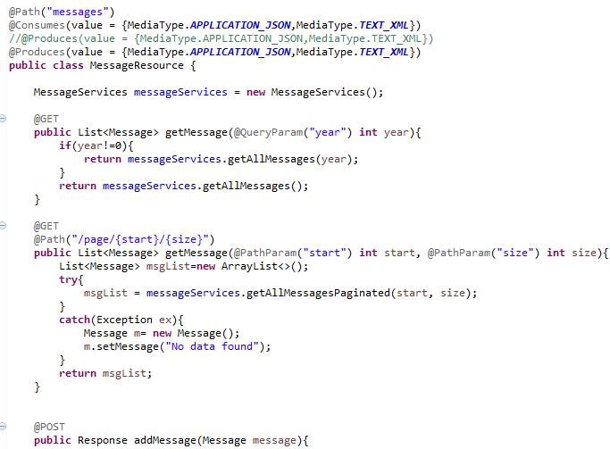
    3. 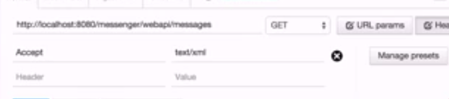
    4. 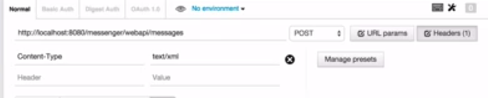

Annotations used:

1. @path
2. @get,@put,@Delete,@Post
3. @Produces
4. @consumes
5. @XMLRootElement
6. @xmlTransient
7. @pathParam
8. @QueryParam
9. @matrixParam. @HeaderParam, @CokieeParam
10. @context and uriInfo, HttpHeaders
11. @beanParam
12. @Provider

# DurgaSoft

1. Intro for Web services
   1. 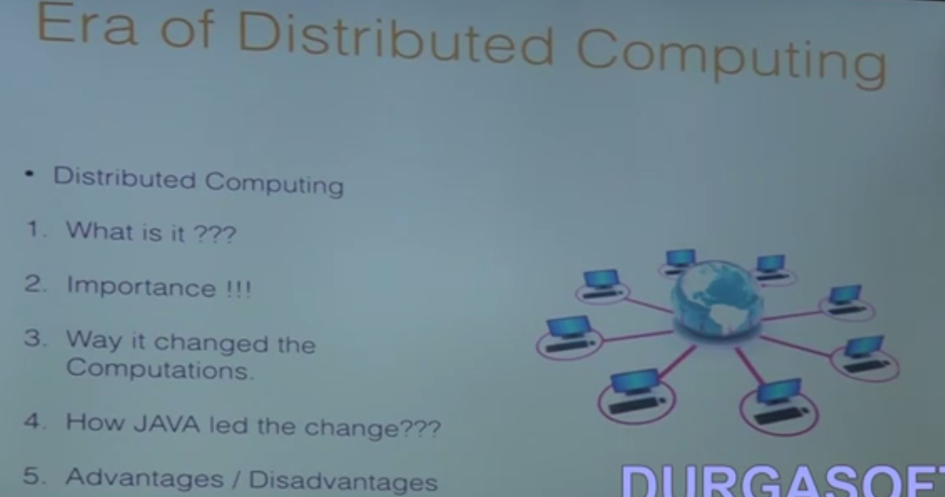
   2. 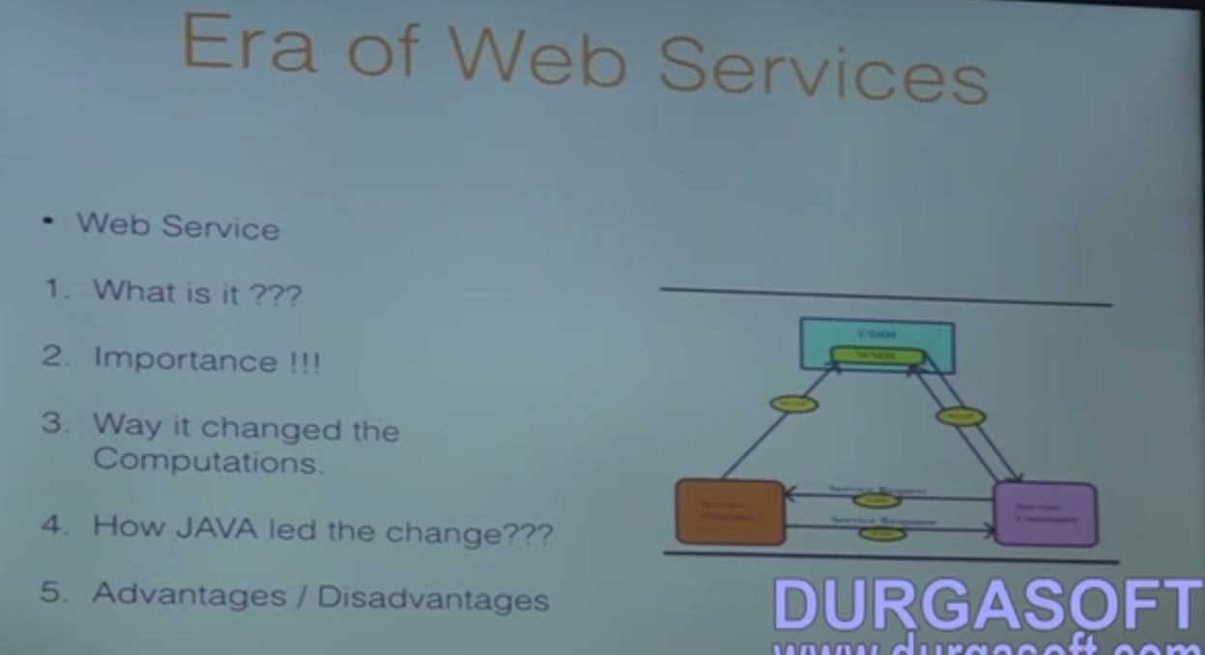
   3. 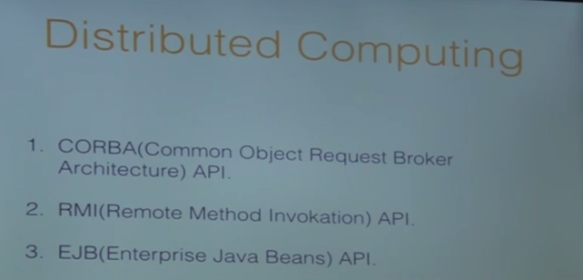
   4. 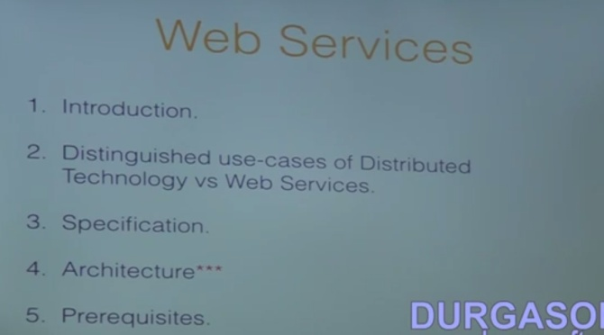
   5. 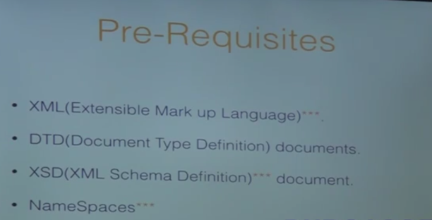
   6. 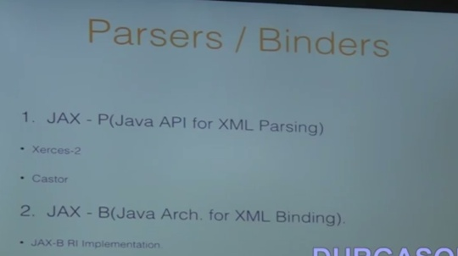
   7. 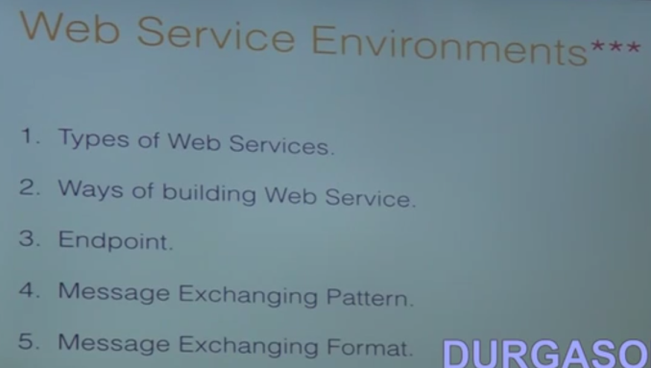
   8. 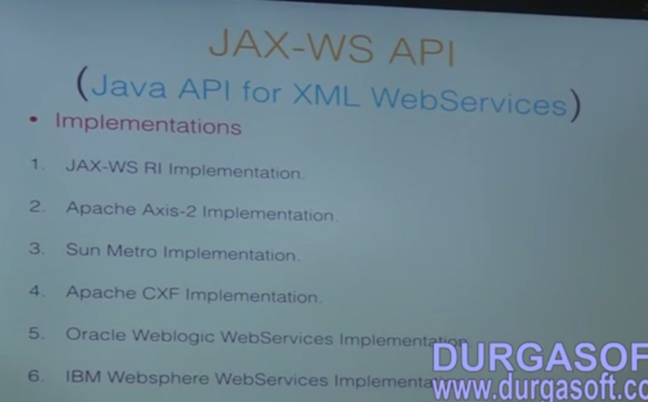
   9. 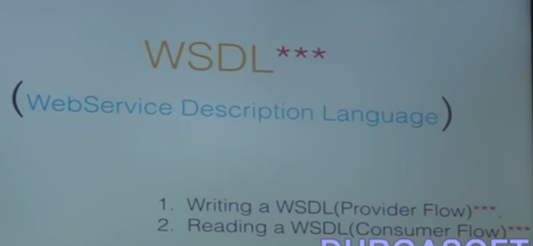
   10. SOAP - Simple object access protocal
   11. 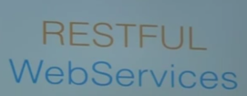
   12. 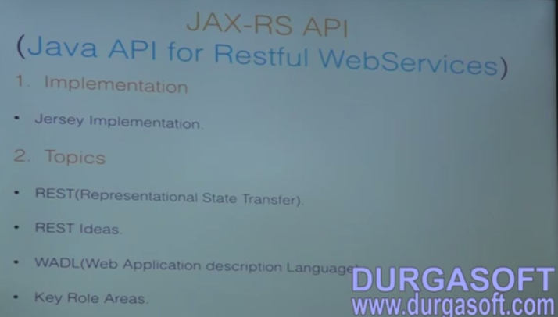
   13. SOAP Vs REST
   14. 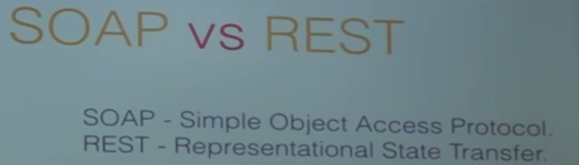
2. Pre-requesties
   1. 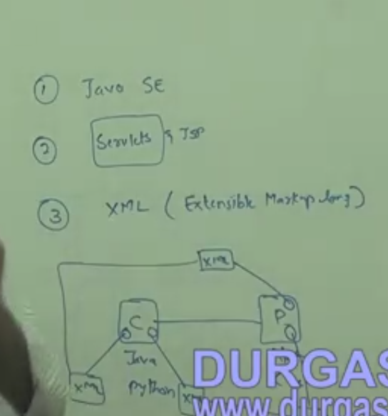
   2. 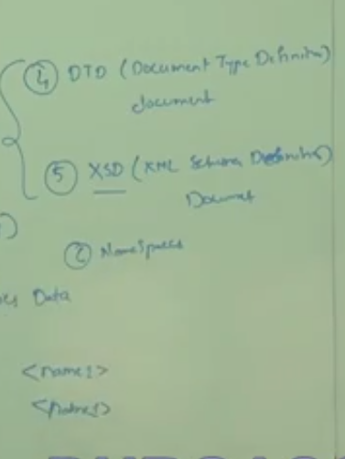
   3. 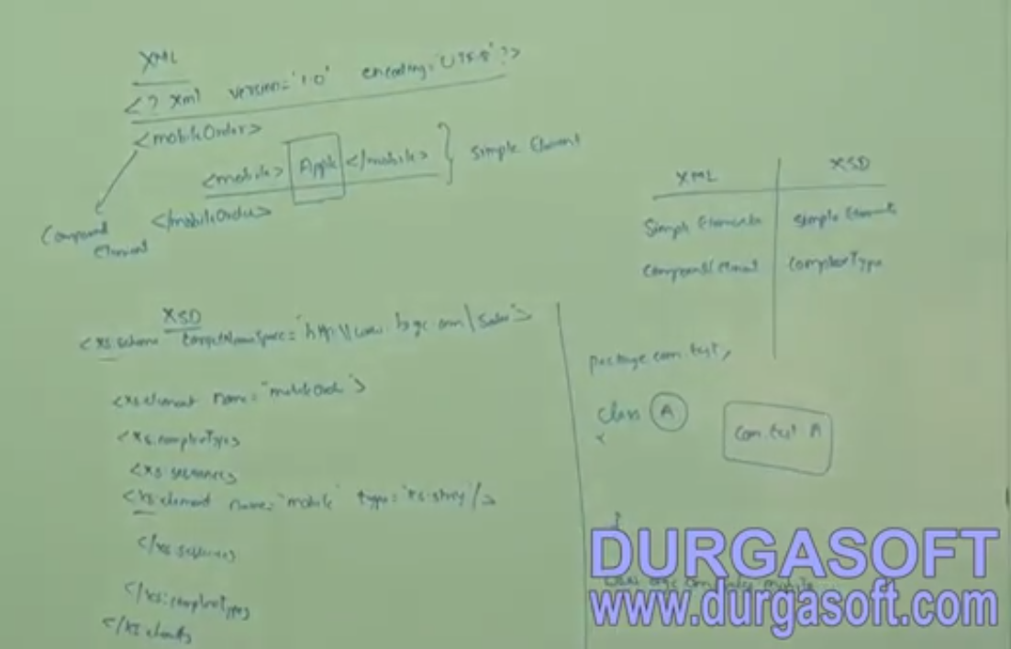
3. Web Service Use Case
   1. 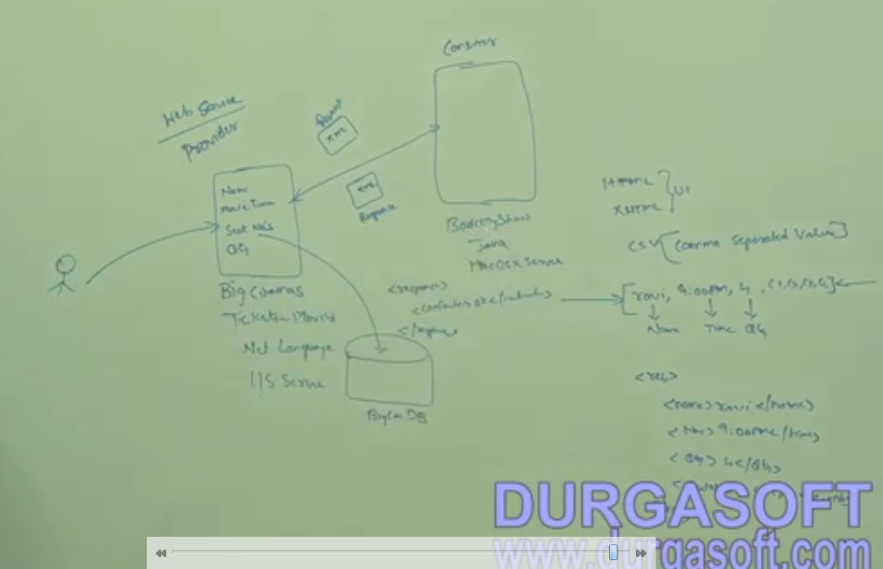
4. WebServices Architecture
   1. 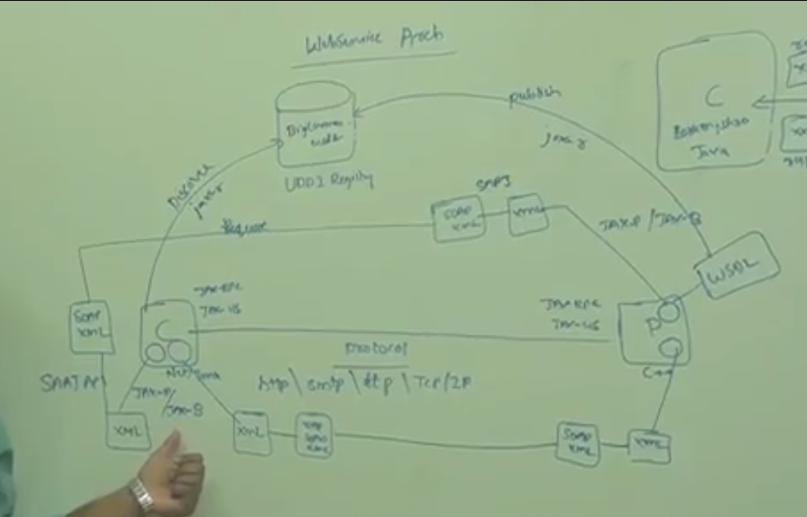
   2. UDDI- Universal Description and discovery integration
   3. SAAJ - Soap API for attachment with java(Converting XML <-> SOAP)
   4. JAX RPC / JAX WS - A Provider and consumer applications
   5. JAX P/JAX B - XML parsing /XML Binding
   6. JAX R - Java API for XML Registry
5. Web Services Interview
   1. What kind of web services u develop
      1. JAX RPC API
      2. JAX WS API
      3. 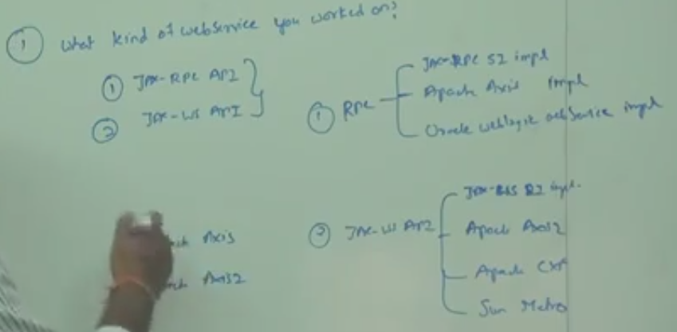
   2. What is SOAP and why are u using it
      1. Simple object access protocol
   3. what are use cases which drives the SOAP protocol to be used in web services
   4. Diff bet SOAP and REST
      1. Simple Object access protocol Vs Representational state transfer

|  |  |
| --- | --- |
| **Simple Object access protocol** | **Representational state transfer** |
| Only XML | All the mime types |
| Integrated with any type of protocol. Ex. Http, TCP-IP, SMTP, FTP | Only HTTP. Since it is designed for that |
| Documented as WSDL (Web Services Description language) | Documented as WADL (Web application description language) |

* 1. What is JAXB
     1. XSD - XML Schema Document
     2. Marshalling and Un Marshalling
     3. 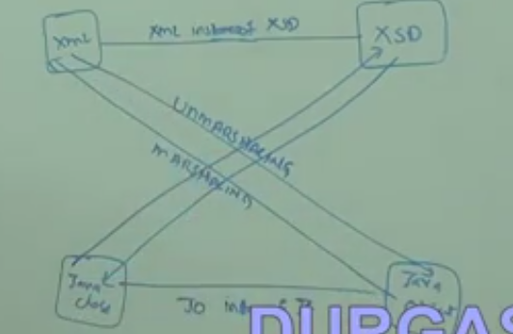
  2. What is UDDI
     1. Universal description and discovery integration registry
     2. it is common location to share our WSDLs
     3. 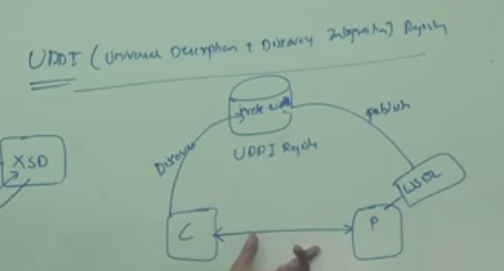

1. Web service developer certified exam
   1. 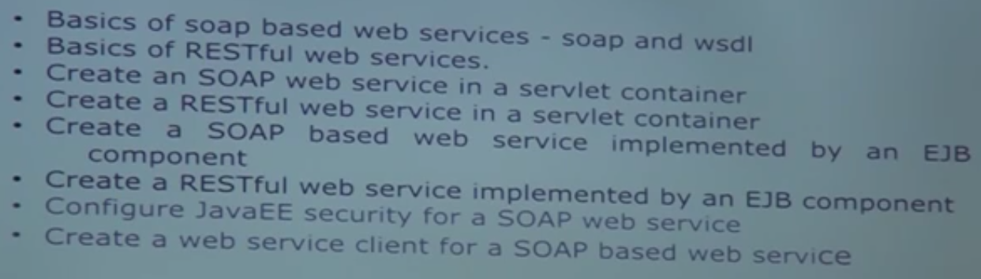
   2. 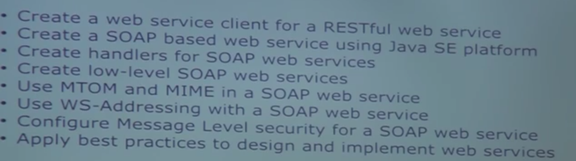
   3. WSI - Web service interoperability organisation

# MVR Web services

1. Introduction
   1. 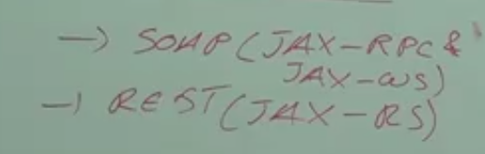
2. Webservice Architecture-Part 1
   1. 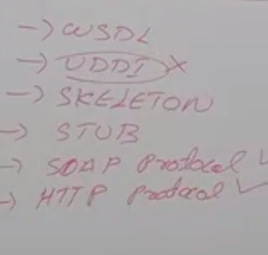
   2. 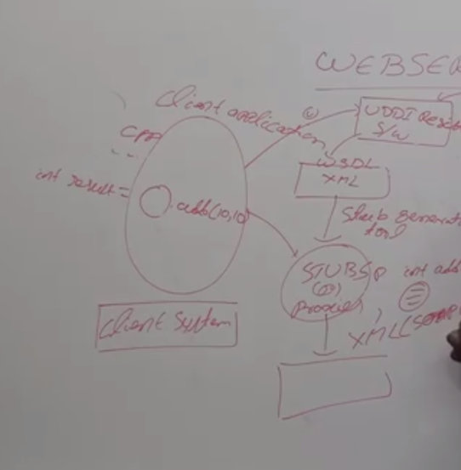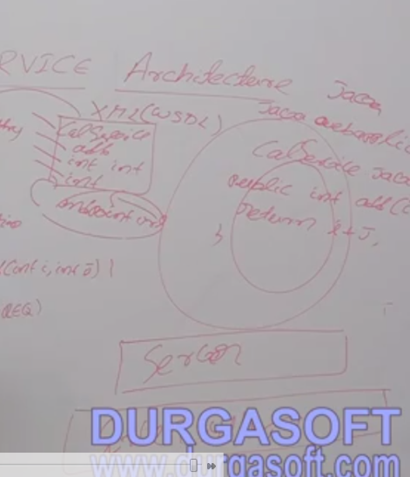
3. Webservice Architecture-Part 2
   1. 4 Java APIs : JAX-RPC, JAX-M, JAX-WS, JAX-RS.
4. Webservice Architecture-Part 2
5. Webservices-Java Webservice API's
   1. 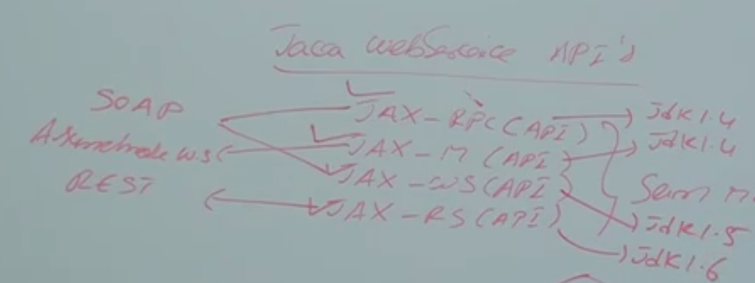
   2. JAX-M(Java API for XML - messaging) for Asynchronies and JAX-RPC(Java API for XML - Remote procedure call),JAX-WS(Java API for XML - Web service),JAX-RS(Java API for RESTful) for synchronies.
   3. Asynchronies web service: Client makes a request to service, without expecting a response.
   4. Synchronies web service: Client makes a request to service, with expecting a response.
   5. JAX-RPC Implementation
      1. Comes with JDK1.4
      2. Both SOAP Services or SOAP Web services Client
      3. 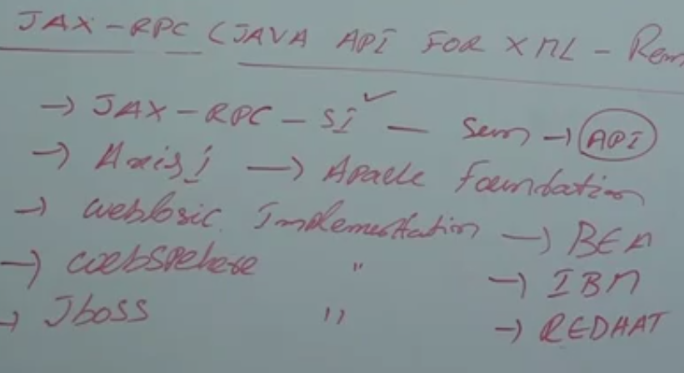
   6. JAX-WS
      1. 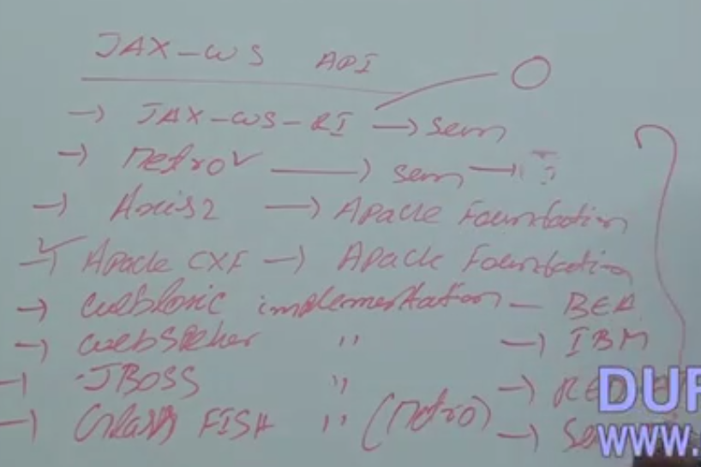
   7. JAX-RS
      1. 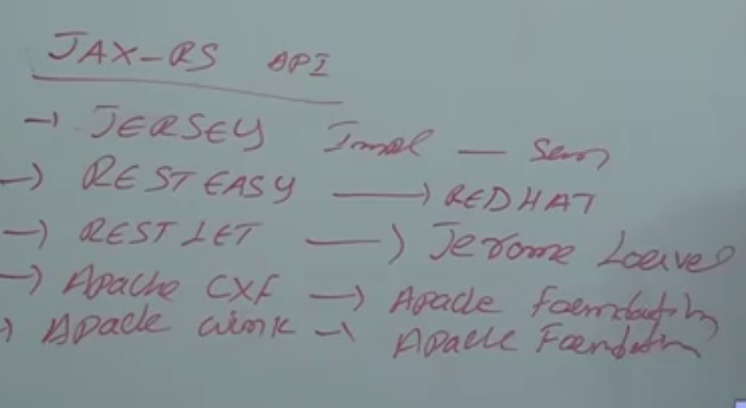
   8. JAX-M - It is not widely used. the messaging services is done thru JMS.
6. First Webservice Example Using Axis1 Implementation Using Eclipse Part 1
7. First Webservice Example Using Axis1 Implementation Using Eclipse Part 2.
8. Axis1 Webservice Client using Eclipse-Part 1
   1. two types : Proxy based client and DII(Dynamic invocation interface) Client
   2. Proxy based client is the client uses the stubs in client side and use the stubs to invoke the web services.
   3. web provider will provide the classes which the client uses to invoke the client.
   4. 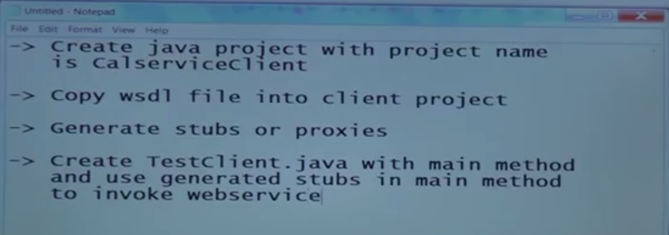
   5. 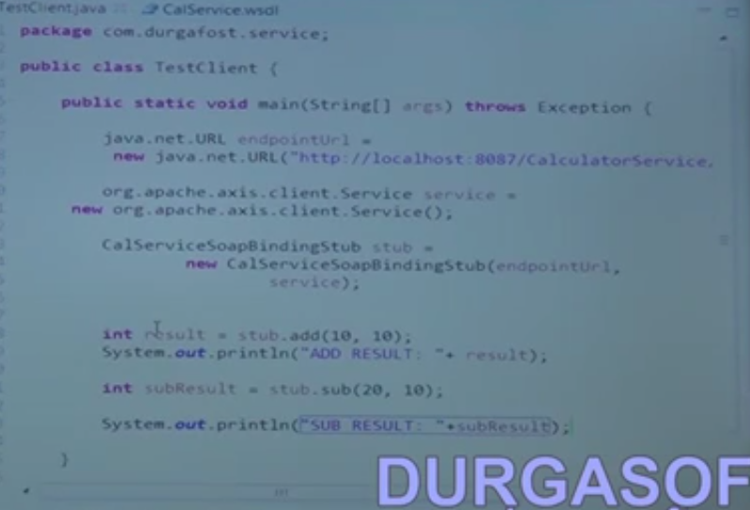
9. Axis1 Webservice Client using Eclipse-Part 2
10. Axis2 Webservice Using Eclipse
    1. 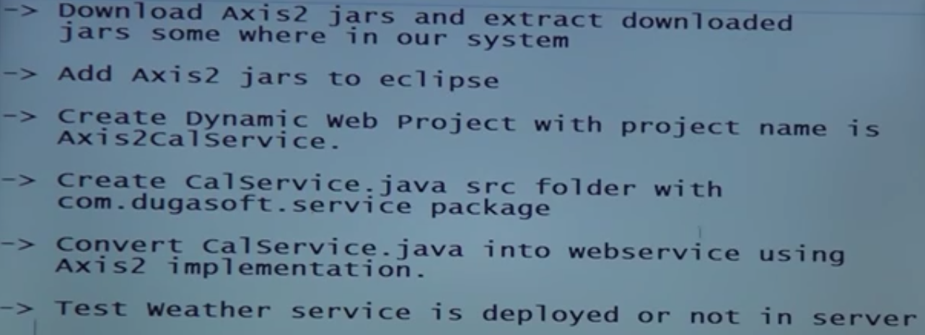
11. Axis2 Webservice Client Using Eclipse

# RESTFUL Services

1. Short Intro
   1. 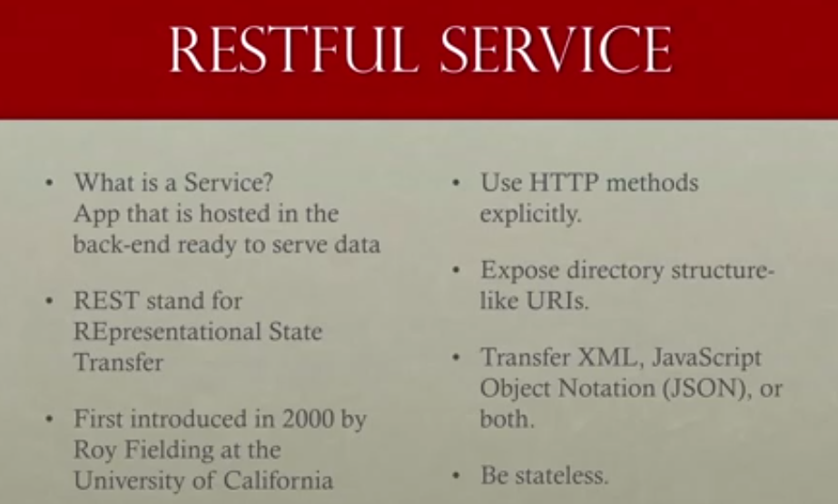
   2. 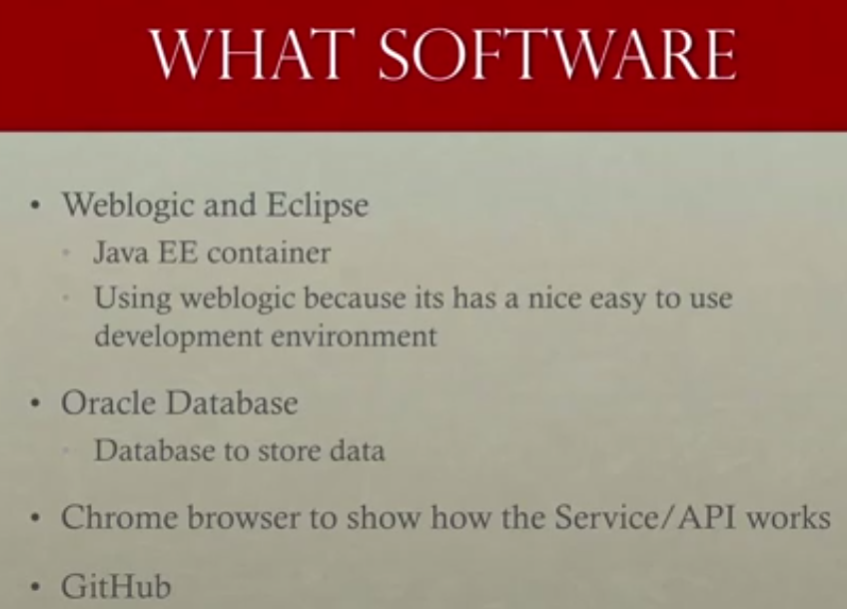
   3. 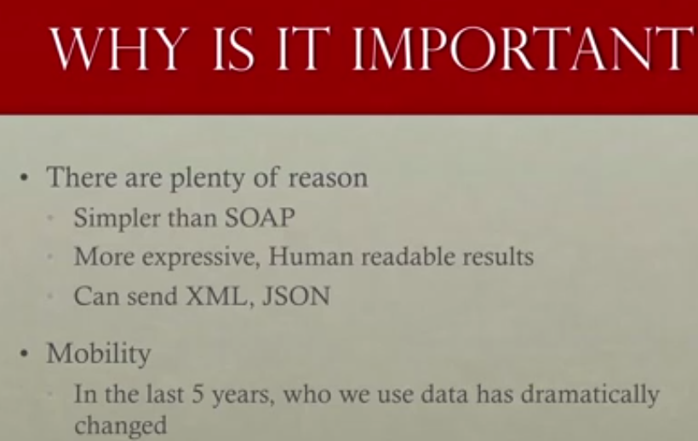
2. Create a REST services
   1. 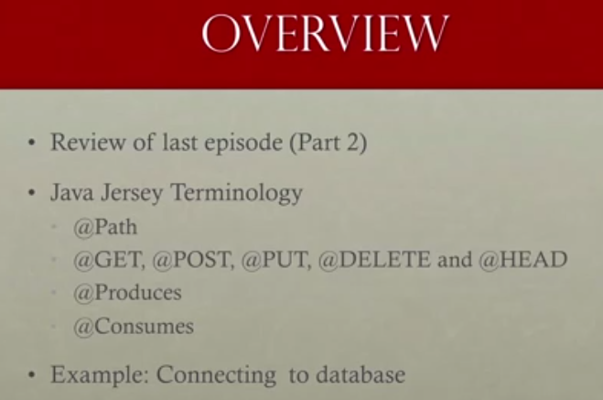
   2. Sample rest services is created.
3. Connect to a database
   1. 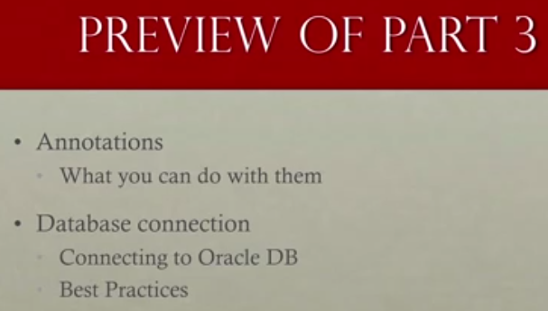
   2. 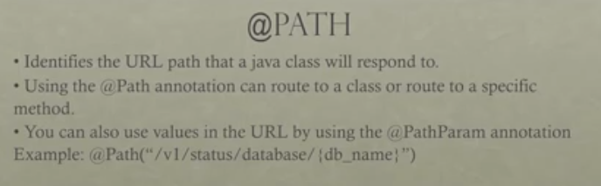
   3. 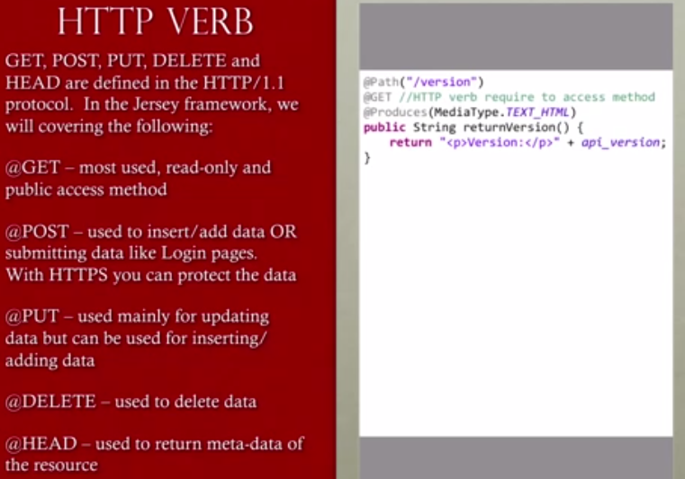
   4. 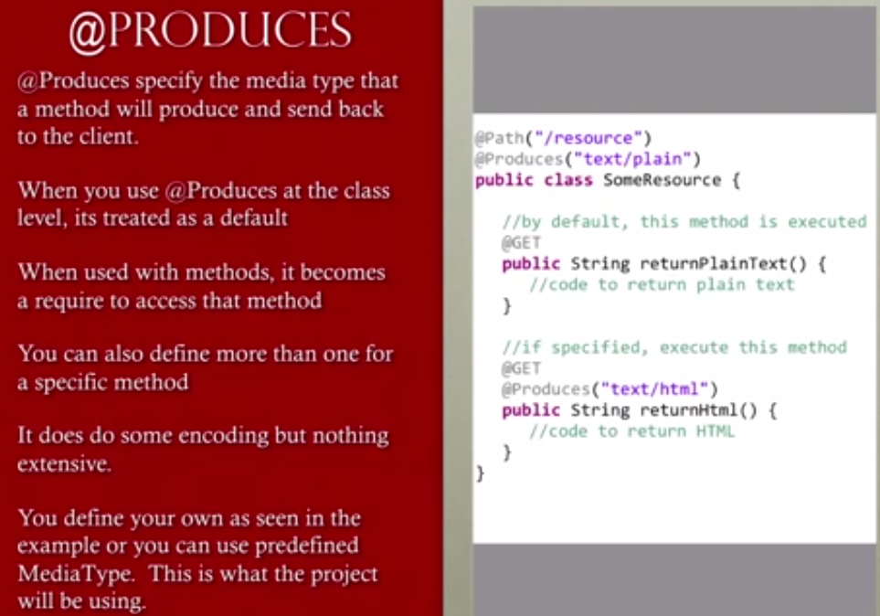
   5. 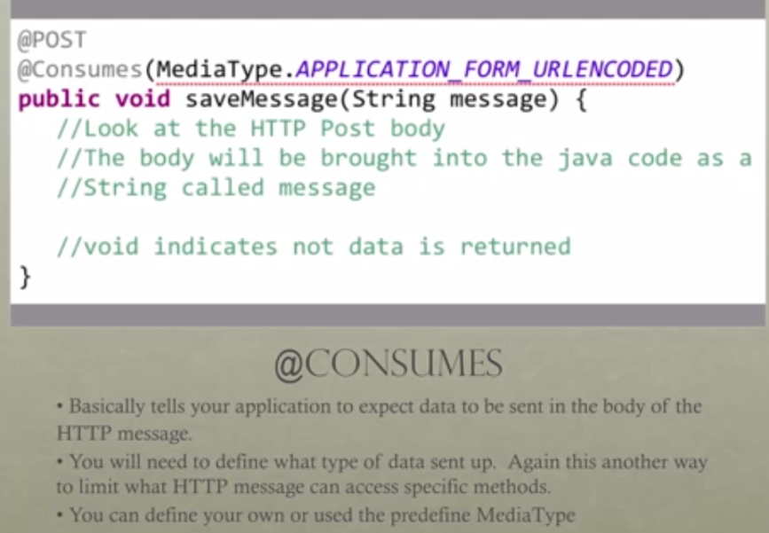
   6. 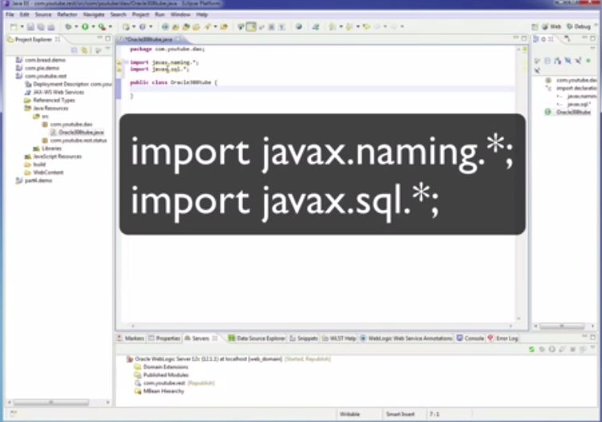
4. Implementing search operation
   1. 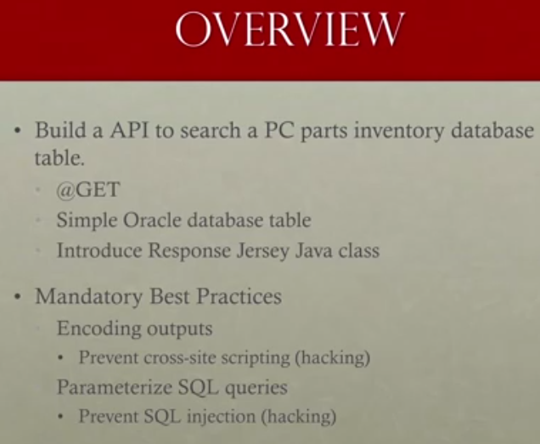
5. Search using get
6. submit using POST

# SOAP UI

## Web Services: (Chapter 1) - 1. SOAP Web Services 01 - Introduction To Web Services

1. SOAP Web services (JAX-WS)
2. REST Web Services (JAX-RS)

## SOAP : (Chapter 2) - 2. SOAP Web Services 02 - Web Service Jargon

1. 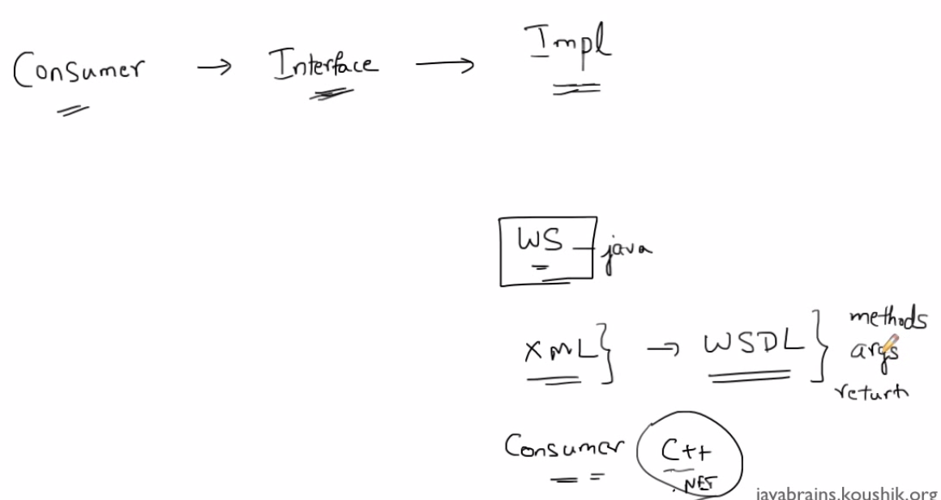
2. 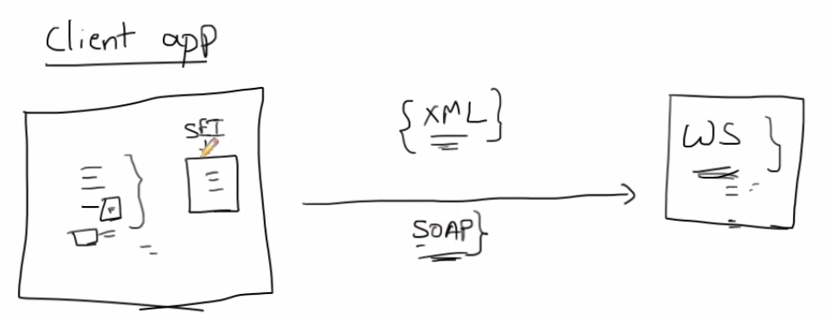
3. WSDL (Service in XML Format)
4. UDDI (Umiversal Discription description and interface)(Directory publisher their webservices)
5. SOAP(Simple object access protocol) (XML format encode and decode messages)
6. SEI – Services end point interface. SEI is class file which takes care of converting the java code to SOAP object.

## Writing a client from Stub : (Chapter 3) - 3. SOAP Web Services 03 - Writing a Web service Client Stub generation

1. WSDL services and WSDL Port in WSDL XML document is used to get the services name and services port of a web services.
2. Wsimport

## Calling a web services: (Chapter 4) - 4. SOAP Web Services 04 - Writing a Web service Client Calling the Service

1. Calling a webservices

## Setting up Java EE: (Chapter 5) - 5. SOAP Web Services 05 - Setting up Java EE 7 SDK

1. Installing glassfish server

## Create web application: (Chapter 5) - 6. SOAP Web Services 06 - Writing a Web Service Eclipse setup

1. Writing a web services in java

## Create web application: (Chapter 6)- 7. SOAP Web Services 07 - Writing a Web Service Code and Deploy

1. Writing a web services in java

## Create web application: (Chapter 7)- 7. SOAP Web Services 07 - Writing a Web Service Code and Deploy

1. Writing a web services in java

## Create web application: (Chapter 8)- 8. SOAP Web Services 08 - Adding Input Arguments

1. Writing a web services in java

## Create web application: (Chapter 9) 9. SOAP Web Services 09 - Service First and Contract First Web Services

1. Service first and contract fist

## WSDL PARTS: (Chapter 10,11,12,13)

1. Structure of a WSDL
2. Types
3. Message
4. Porttype
5. Binding
6. Services

## jAXB PARTS: (Chapter 14,15)

Cunstructing a XML

## Exception Handling: (Chapter 16)

1. Exception handling
2. declare the web services class throwing exceptions
3. Fault message will be added to the wsdl with the respective Exception codes

## SOUP UI: (Chapter 17)

1. SOAP UI Plugin for eclipse

## Web services explorer: (Chapter 18)

Web services Explorer

## End point Web services tester: (Chapter 19)

1. EndPoint.publish() - Publish the web services.
2. Metro comes with the JDK publish the web services

## WSImport revisited: (Chapter 20)

1. -d specify the directory
2. -keep - keeps the Java files
3. -s - Specifies the java src files to be saved
4. -verbose and - quiet -gives detailed output and less output on concole
5. - p - used to import the java files in specified package name

# Security

There are two types of security constraints in REST:

1. Basic
2. 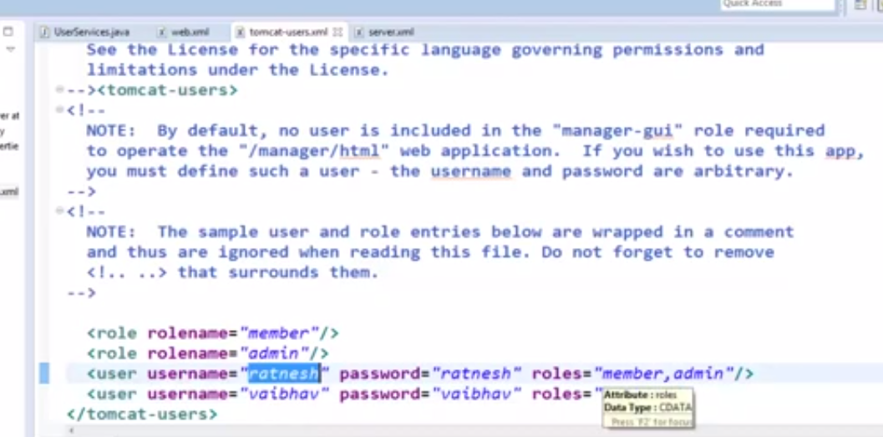
3. use <Security-Constraint> tag in Web.xml
4. 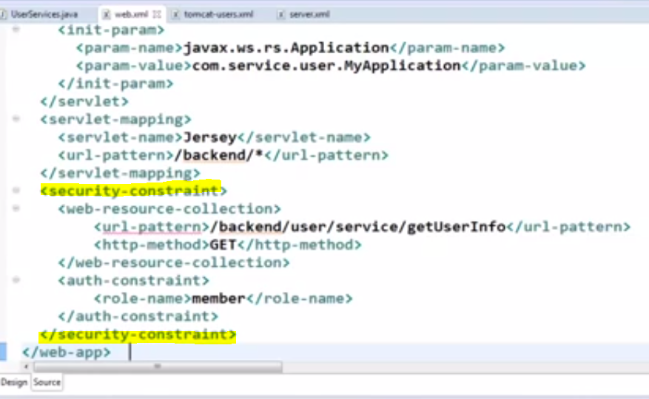
5. Use <Login-Config> tag to confugure user name and password
6. 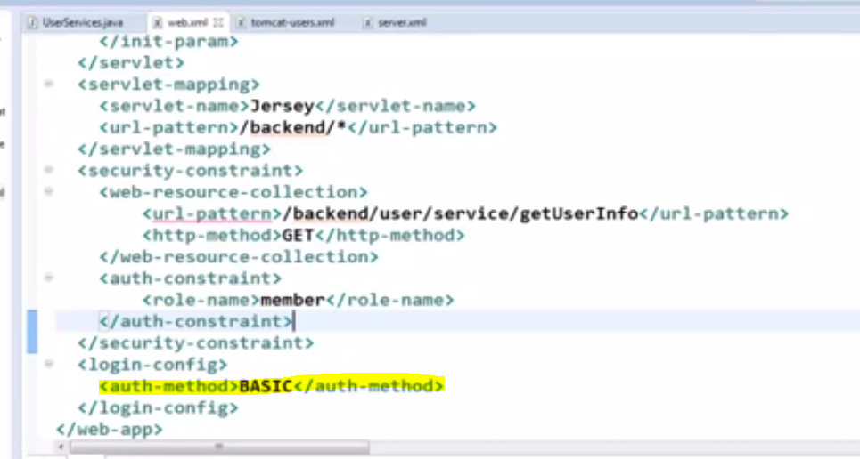
7. when we call the web service it will pop up a authentication in the browser

# Using SSL

<user-data-Constraint>

<transport-guarentee> CONFIDENTIAL </ transport-guarentee>

</user-data-Constraint>

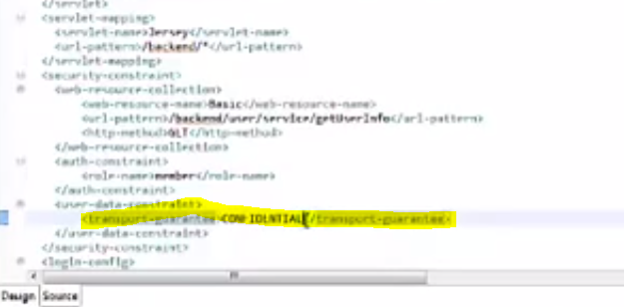

Open server.xml

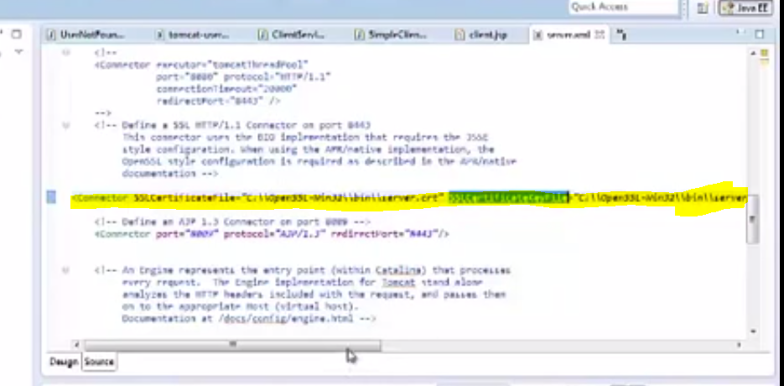

# Secure RESTful web service using BASIC authentication (1)

1. 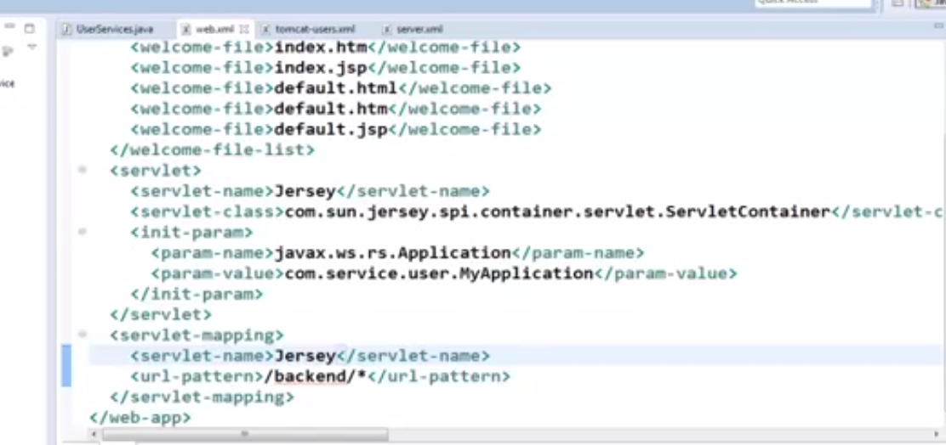
2. A place where define the user roles.
3. 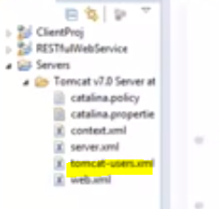
4. 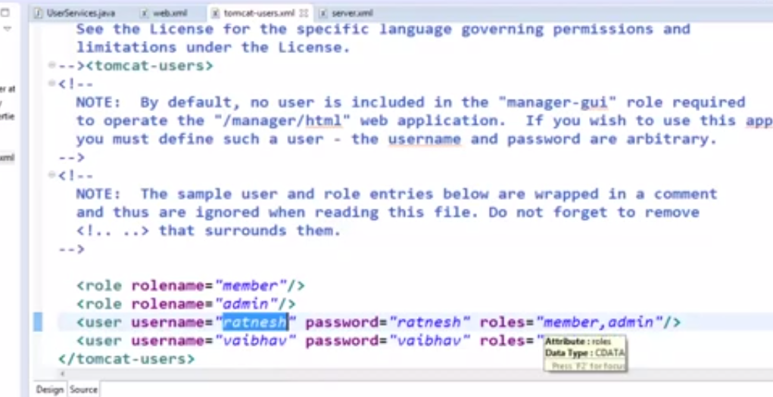
5. Security constraint tag.
6. 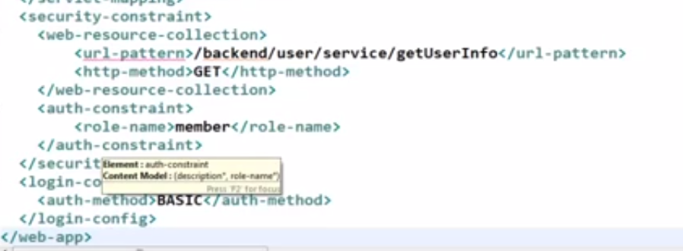
7. 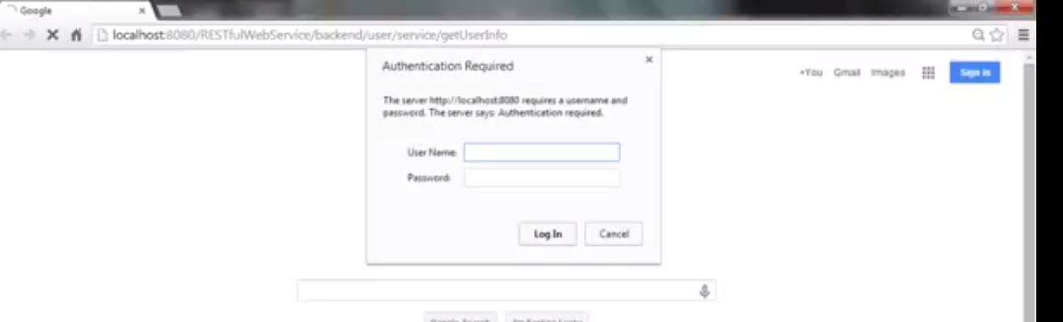
8. Calling a URL in java client
   1. Client for calling without authentication.
   2. 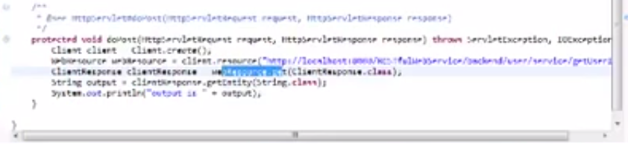
   3. Now with http authentication
   4. Client.addFilter(new httpBasicAuthFilter("username","Password"));
   5. 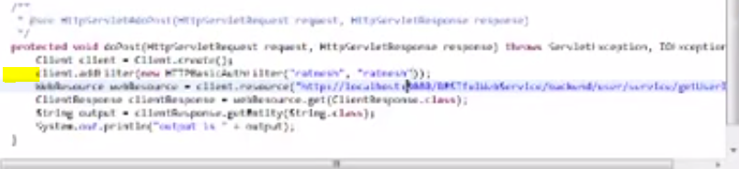

# Secure RESTful web service using SSL part-I

1. SSL - Secured Socket layer.
2. they are used in sites that involve sensitive data.
3. it can be accessed only in https.
4. 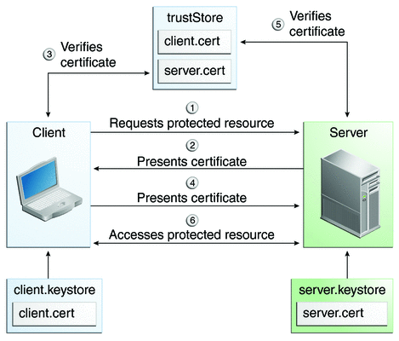

# Consuming a REST Web services

1. Copy and download all the Jersey jars in lib folder of the client project.
2. 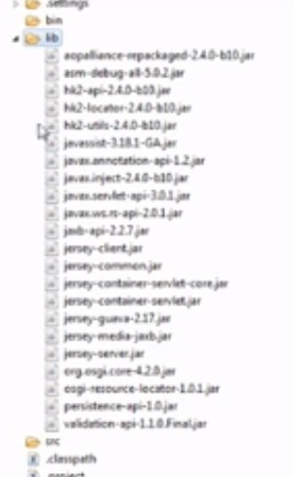
3. Add the jars to classpath
4. 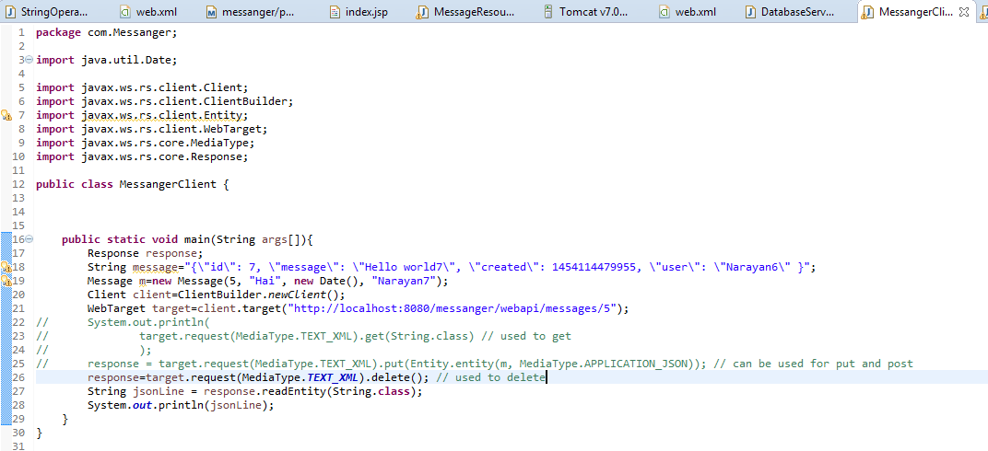
5. Apply the above code for post

# OAuth2

1. 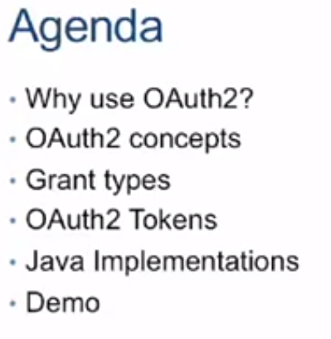
2. 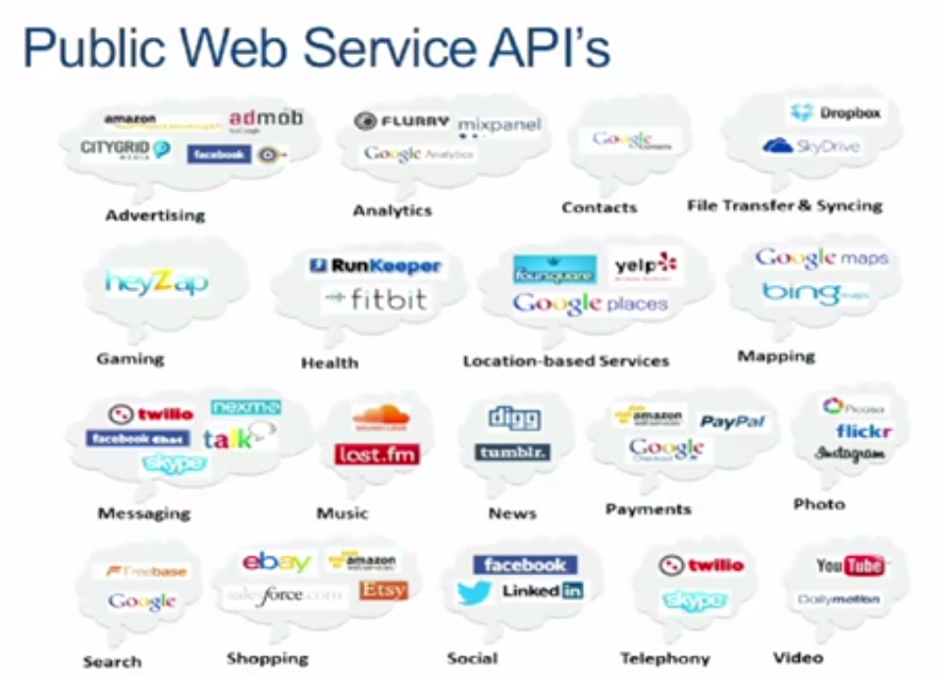
3. 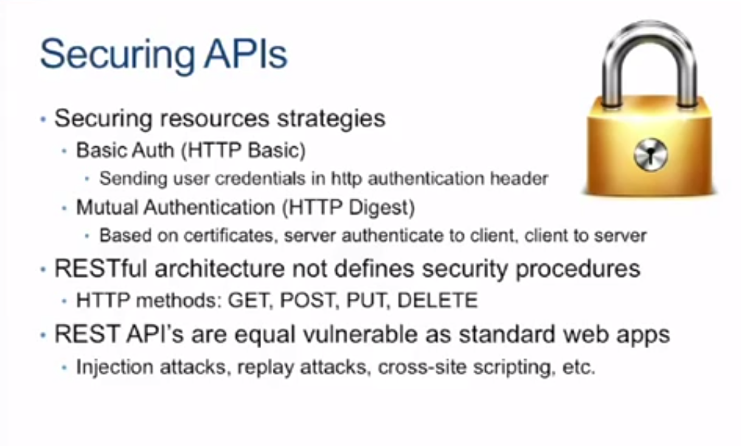
4. 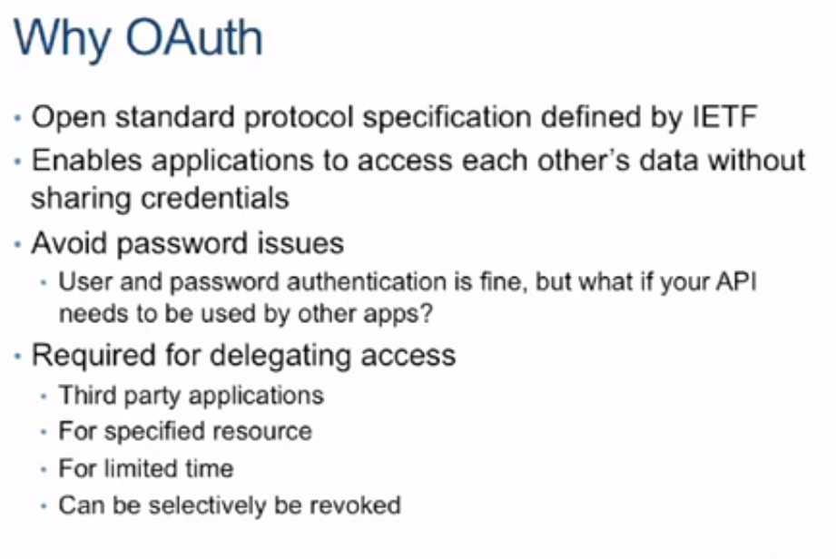
5. 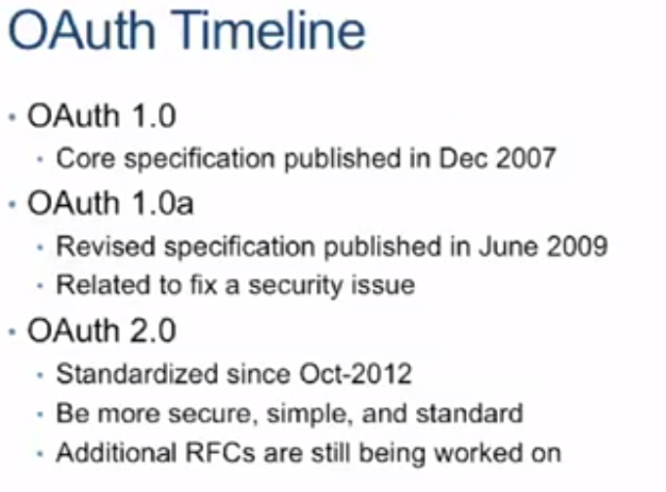
6. 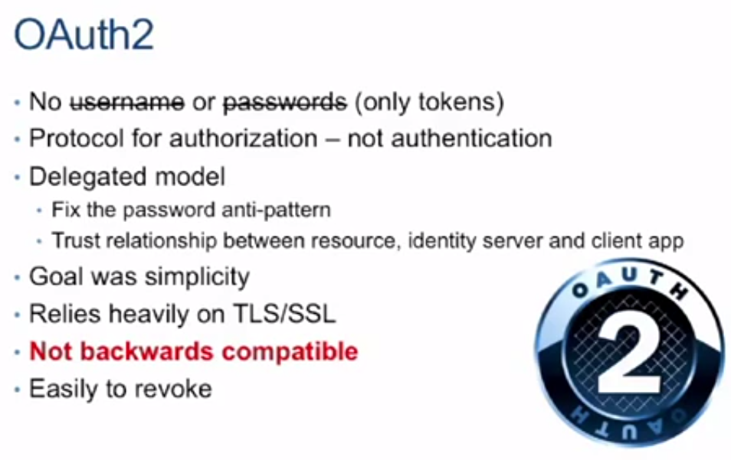
7. 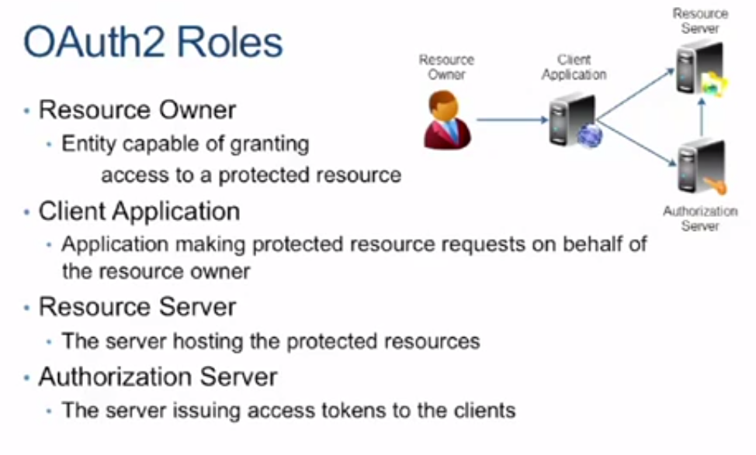
8. 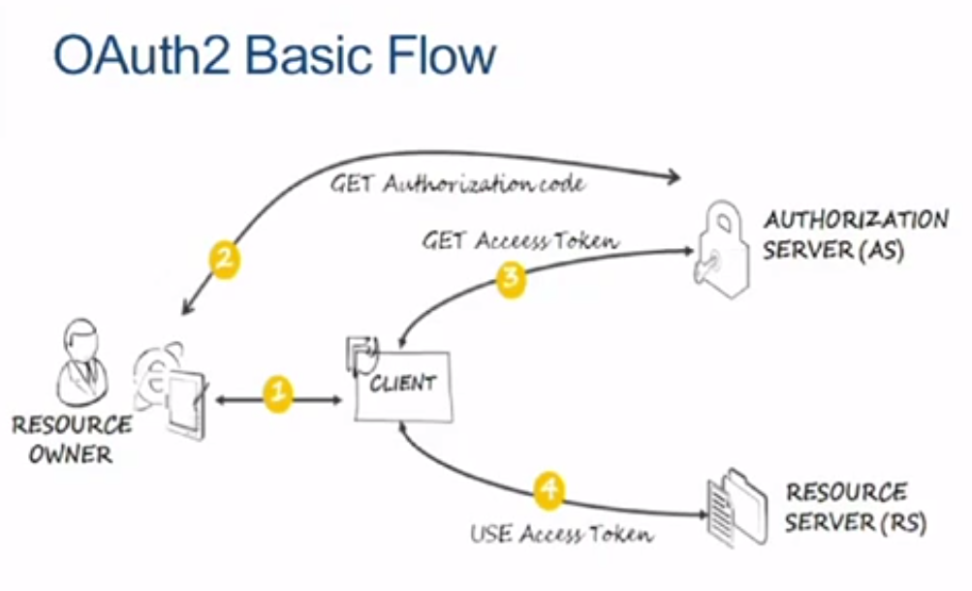
9. 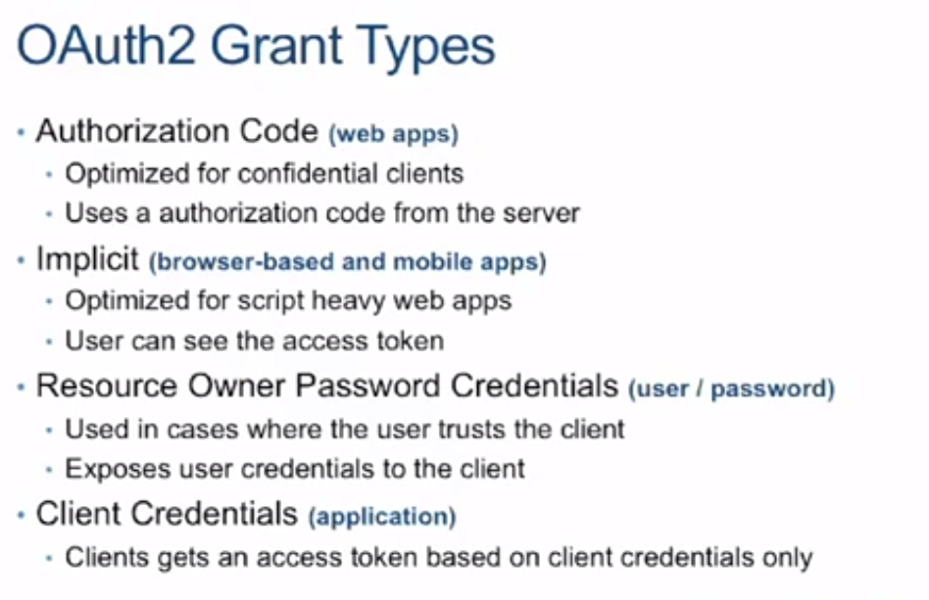
10. 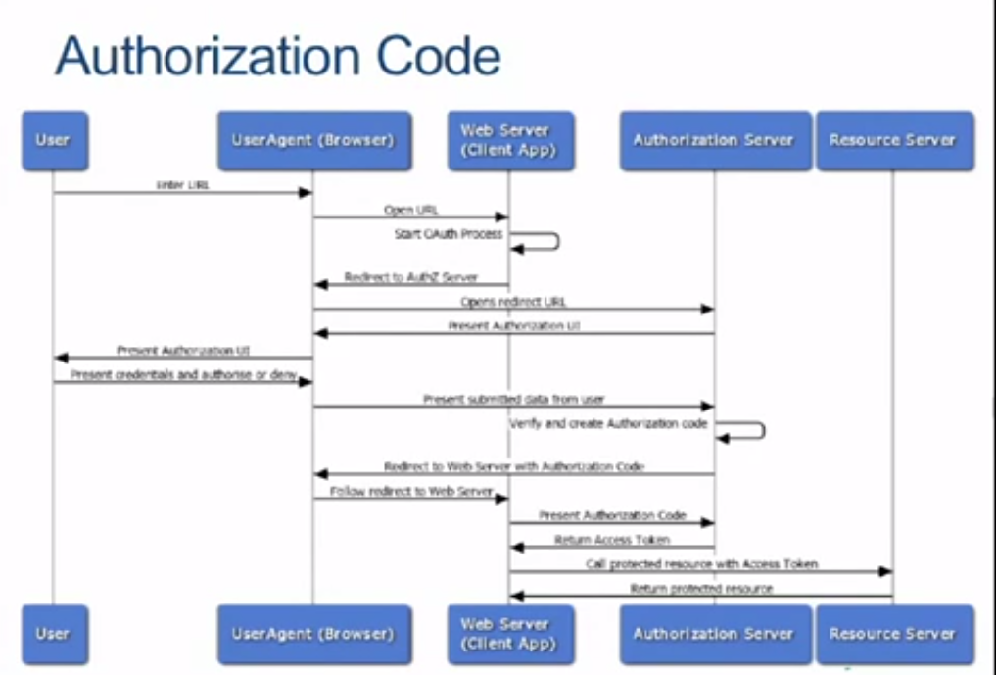
11. 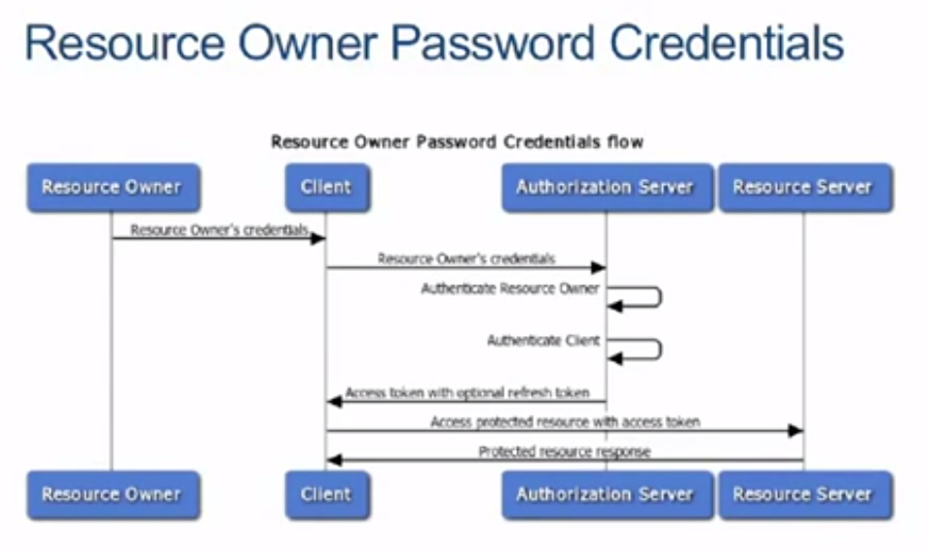
12. 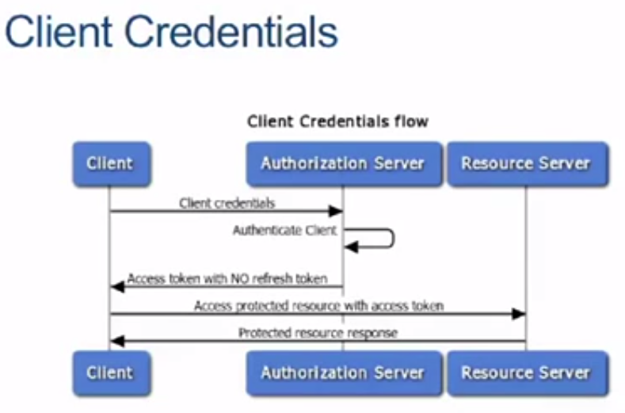
13. 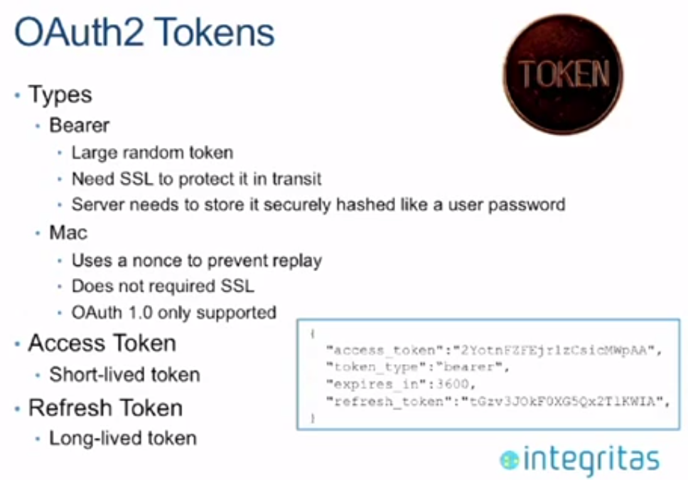
14. 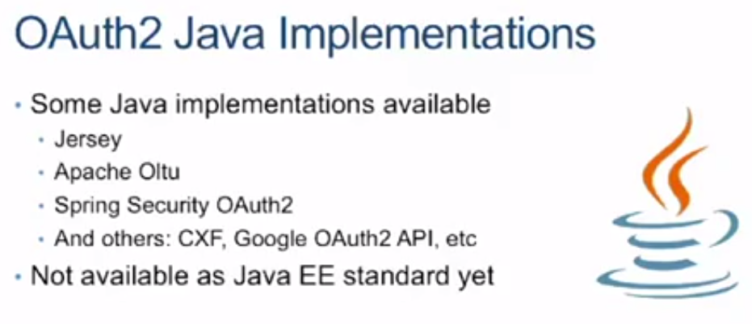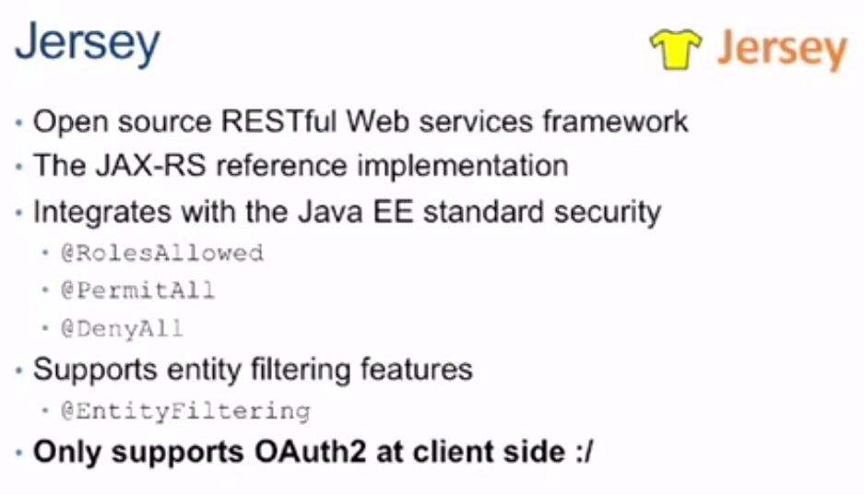
15. 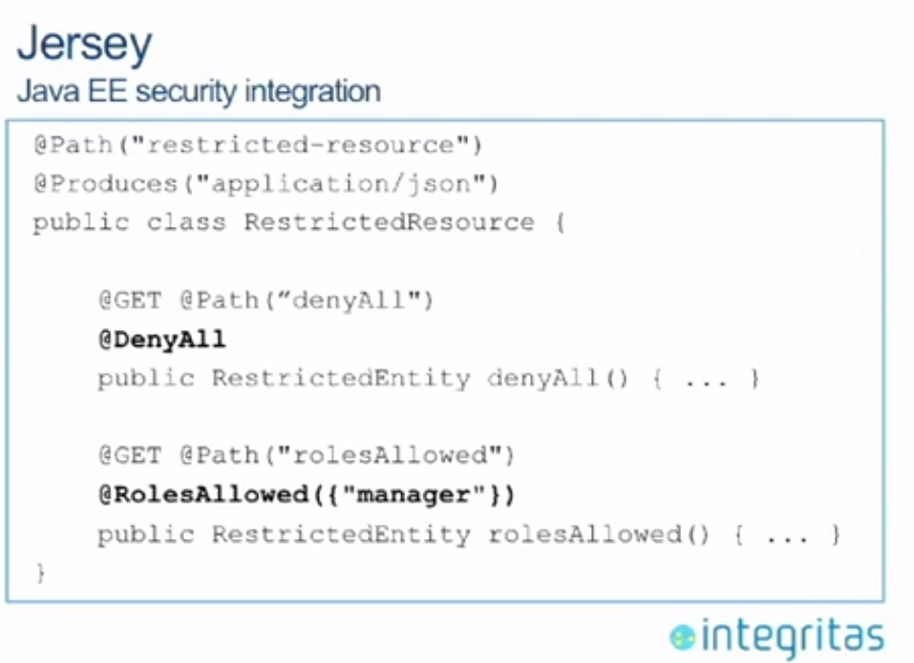
16. 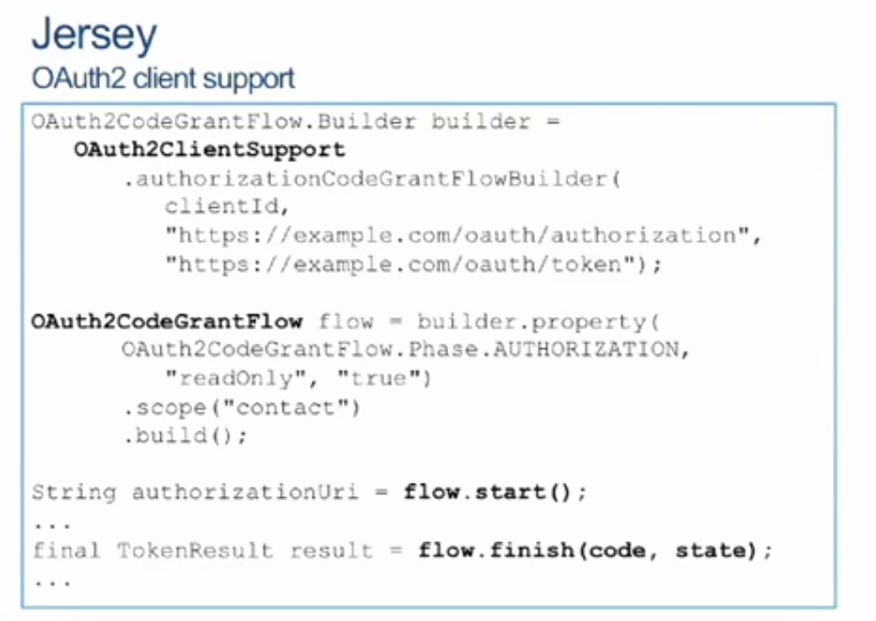
17. 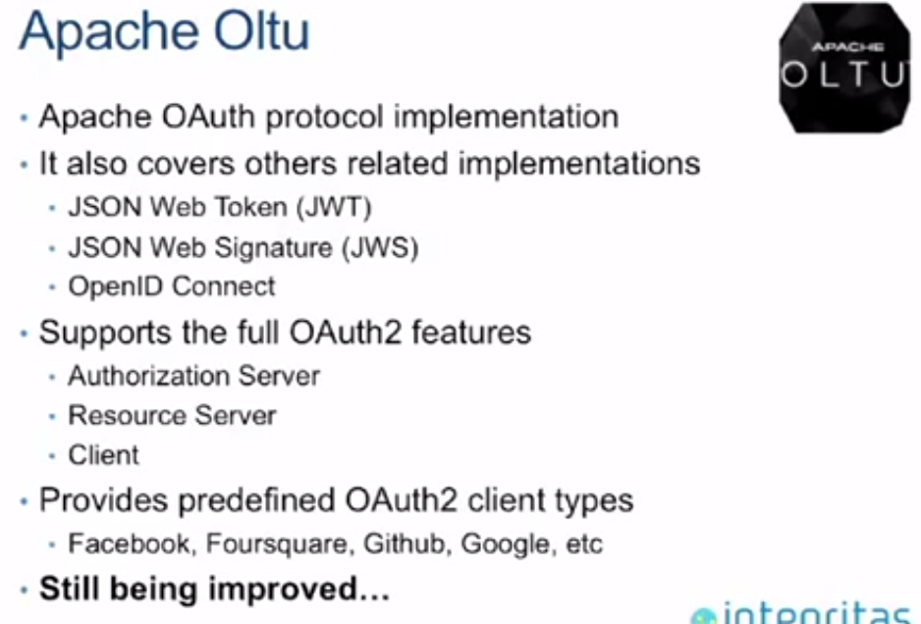
18. 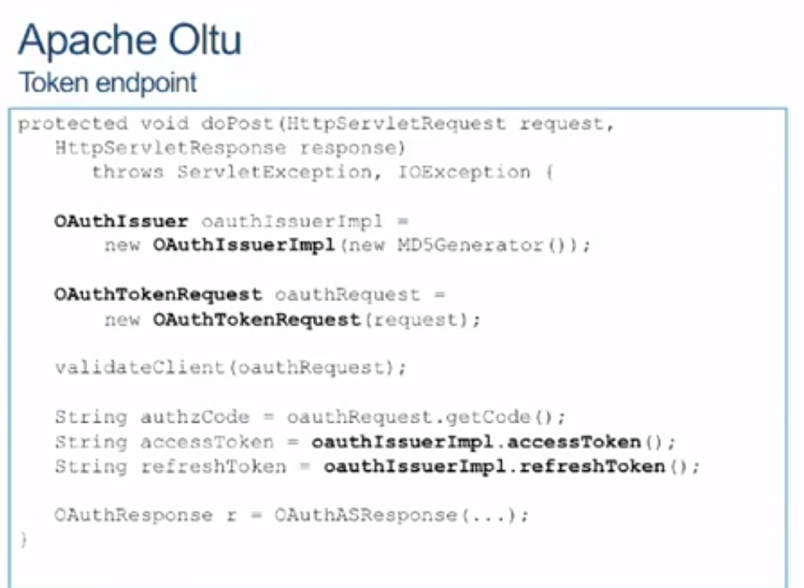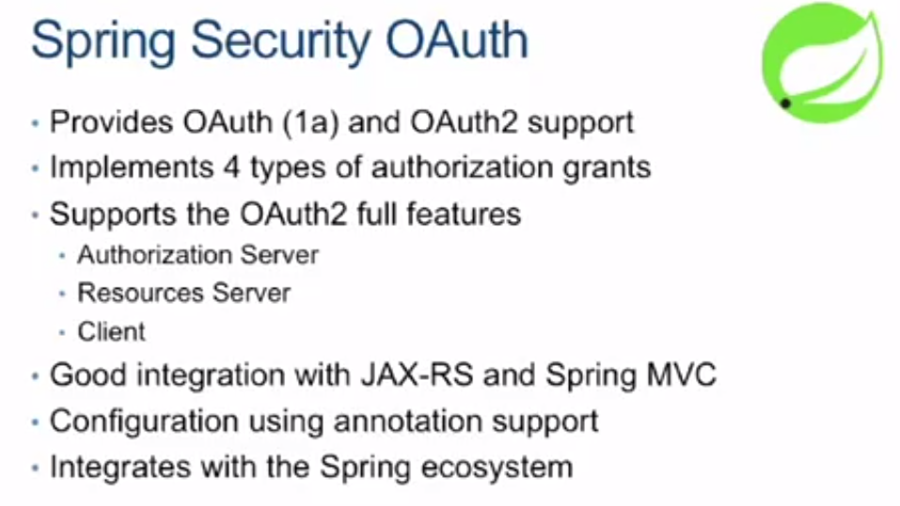
19. 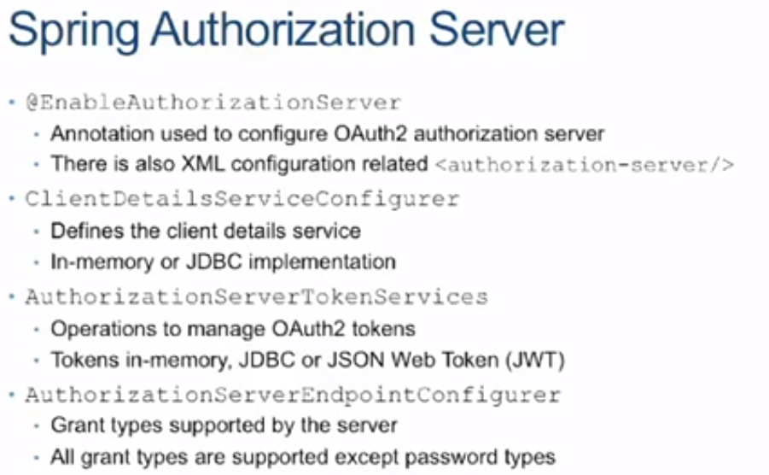
20. 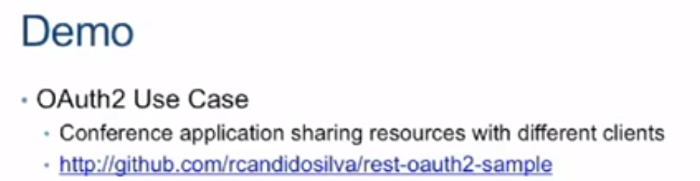
21. 